

Table Of Contents

1.Document Introduction 5

2. Updated Functional requirments 6

1.1 Introduction 6

1.2 Functional requirement lisT 6

Subsystem 1 – User Subsystem 6

Subsystem 2 – Admin Subsystem 6

Subsystem 3 – Procurement Subsystem 7

Subsystem 4 – Finance subsystem 7

Subsystem 5 – Inventory subsystem 7

Subsystem 6 – Vendor subsystem 7

Subsystem 7 – Report Subsystem 7

1.3 Functional requirements description 8

Subsystem 1 – User Subsystem 8

Subsystem 2 – Admin subsystem 13

Subsystem 3 – Procurement Subsystem 30

Subsystem 4 – Finance Subsystem 38

Subsystem 5 – Inventory Subsystem 42

Subsystem 6 – Vendor Subsystem 48

Subsystem 7 – Report Subsystem 57

1.4 Conclusion 62

2. Functional requirement Client Sign OFF 63

1. Technical Use Case Diagram 64

1.1 Introduction 64

1.2 Use Case Diagrams 64

1.2.1 Subsystem 1 - User Subsystem 65

1.2.2 Subsystem 2 – Admin Subsystem 66

1.2.3 Subsystem 3 - Procurement Subsystem 69

1.2.4 Subsystem 4 - Finance Subsystem 71

1.2.5 Subsystem 5 - Inventory Subsystem 72

1.2.6 Subsystem 6 - Vendor Subsystem 73

1.2.7 Subsystem 7 - Reporting Subsystem 74

1.3 Conclusion 74

2. Proposed design principles & Example Wireframes 75

2.1 Introduction 75

2.2 Design principles & Example Wireframes 75

2.3 Conclusion 97

3. Entity Relationship Diagram 98

3.1 Introduction 98

3.2 Entity relationship Diagram 98

3.3 Conclusion 99

4. Technical specifications 100

4.1 introduction 100

4.2 Technical specification of chosen elements 100

4.2.1 SQL 100

4.2.1.1 What is SQL? 100

4.2.1.2 What is SQL Server? 100

4.2.1.3 How the database is set up 100

4.2.1.4 Connection of the database to the .Net API 100

4.2.2 Angular 101

4.2.2.1 What is Angular? 101

4.2.2.2 Why use Angular? 101

4.2.3 .Net Core Web API 102

4.2.3.1 What is .Net Core Web API? 102

4.2.3.2 What is the REST architecture? 102

4.2.3.3 How does this connect to the database and the frontend? 103

4.2.4 ASP.Net Identity 104

4.2.4.1 What is ASP.Net Identity? 104

4.2.4.2 Why ASP.Net Identity? 104

4.2.4.3 How to use ASP.Net Identity 104

4.2.5 ML.NET 105

4.2.5.1 What is ML.NET? 105

4.2.5.2 Why use ML.NET? 105

4.2.5.3 How to use ML.NET 105

4.2.6 Npmjs – Scheduling Component 106

4.2.6.1 What is Npmjs? 106

4.2.6.2 Why use Npmjs. 106

4.2.6.3 How to use Npmjs 106

4.2.7 Email kits and components - NET Core.Mailkit and Emails mailto 107

4.2.7.1.1 What is Mailkit? 107

4.2.7.1.2 Why use Mailkit? 107

4.2.7.1.3 How to use Mailkit. 107

4.2.7.2 Mailto 108

4.2.7.2.1 What is Mailto? 108

4.2.7.2.2 Why use Mailto? 108

4.2.7.2.3 How to use Mailto. 109

4.2.8 Microsoft Azure – Cloud Computing Service 109

4.2.8.1.1 What is Azure? 109

4.2.8.1.2 Why use Azure? 110

4.2.8.1.3 How to use Azure. 110

4.2.9 Windows forms 110

4.2.9.1.1 What is Windows forms? 110

4.2.9.1.2 Why use Windows forms? 110

4.2.9.1.3 How to use Windows forms. 111

4.2.10 ASP.NET core Export to excel package 111

4.2.10.1.1 What is Export to excel? 111

4.2.10.1.2 Why use Export to excel? 111

4.2.10.1.3 How to use Export to excel. 112

4.3 conclusion 113

5. Network layout specification 113

5.1 introduction 113

5.2 Network layout 114

5.3 conclusion 114

6.Updated Complexity matrix 115

6.1 introduction 115

6.2 complexity matrix 115

6.3 conclusion 117

7. Document Conclusion 118

8. Team Sign off 119

9. Client Document Sign OFF 120

# 1.Document Introduction

In iteration 3 we focus on the technical specifications of the Procion system that we are developing. Here we try and gather insight about the second and final update functional requirements, physical usecase diagram, physical ERD, technical specifications, network specifications, component library and wireframes, SQL Database, and the updated complexity matrix to help us achieve a better understanding of how the system will operate and function. This will bring us closer towards our end goal of building the Procion system.

2. Updated Functional requirments

## 1.1 Introduction

In this section a list of the second and last updated functional requirements will be listed for our proposed system Procion. The second and last updated functional requirements are grouped into the following sub-systems: The user sub-system, Admin sub-system, Procurement sub-system, Finance sub-system, Inventory sub-system, Vendor sub-system and a Report sub-system.

## 1.2 Functional requirement lisT

### Subsystem 1 – User Subsystem

1.1 Login

1.2 Logout

1.3 Forgot password.

1.4 Update password

1.5 View profile.

1.6 Update profile

1.7 View user manual.

1.8 View Help

1.9 View Notification

### Subsystem 2 – Admin Subsystem

2.1 Create employee.

2.2 View employee

2.3 Update employee

2.4 Delete employee.

2.5 Create employee roles.

2.6 View employee roles

2.7 Update employee roles

2.8 Delete employee roles.

2.9 Create Department

2.10 View Department

2.11 Update Department

2.12 Delete Department

2.13 Create Branch

2.14 View Branch

2.15 Update Branch

2.16 Delete Branch

2.17 View Delegation of Authority

2.18 Assign delegation of authority.

2.19 Accept Delegation request

2.20 Revoke delegation of authority

2.21 Create Mandate limits

2.22 View Mandate limits

2.23 Update Mandate limits

2.24 Delete Mandate limits

2.25 Backup system data

2.26 Restore data to system.

2.27 Add Help

2.28 Update Help

2.29 Delete Help

2.30 View all help

### Subsystem 3 – Procurement Subsystem

3.1 Create Procurement Request

3.2 View Procurement Request

3.3 Update Procurement Request

3.4 Delete Procurement Request

3.5 Management mandate approval

3.6 Upload Requisition quotes

3.7 Approve quote

3.8 Place procurement request

3.9 Receive Procurement item

3.10 Upload tax Invoice

3.11 Budget owner Requisition approval

3.12 Upload receipt

3.13 Upload credit card Payment

### Subsystem 4 – Finance subsystem

4.1 Finalize procurement request

4.2 Upload proof of payment

4.3 Create budget allocation.

4.4 View budget allocation

4.5 Update budget allocation

4.6 Delete budget allocation.

### Subsystem 5 – Inventory subsystem

5.1 Create inventory item.

5.2 View inventory item.

5.3 Update inventory item

5.4 Delete Inventory Item

5.5 Create item category.

5.6 View item category.

5.7 Update item category

5.8 Delete Item Category

5.9 Export inventory details

5.10 Generate reorder stock notification.

5.11 Complete Stock Take

### Subsystem 6 – Vendor subsystem

* 1. Create Vendor onboard Request
  2. View Vendor onboard Request
  3. Update Vendor Onboard Request
  4. Delete Vendor Onboard Request
  5. Approve onboard request
  6. Create vendor
  7. View vendor
  8. Update Vendor
  9. Delete vendor
  10. Export Due Diligence Vendor Checklist
  11. Generate Sole Supplier Review Notification
  12. Generate BEE Certificate Expiry Notification

### Subsystem 7 – Report Subsystem

7.1 Generate Approved Vendor Report.

7.2 Generate BEE Spend Report.

7.3 Generate Vendor Spend Report

7.4 Generate Consumable Inventory Management Report.

7.5 Generate Business Unit Allocation Report

7.6 Generate Budget Variance Report

7.7 View Generate Report

## 1.3 Functional requirements description

### Subsystem 1 – User Subsystem

|  |  |
| --- | --- |
| Functional Requirement | Explanation |
| **Requirement number:** | 1.1 |
| **Requirement name (use case name):** | Login |
| **Requirement short description:** | The system should allow the user to log on to the system |
| **Requirement detailed description and constraints:** | **Description:**  Each user will log on to the system with their username and password. The information is then validated using the system’s database and will end either by providing user access to what their authority level allows or by displaying a error message indicating the entered details are incorrect.  **Constraint(s):**   * The user requires internet access |
| **Business rules applicable to this requirement:** | * All passwords must be encrypted and hashed. * The administrative must have added user into the system. |
| **Revision date and Revision number:** | 03/17/2023  Version 2.0 |
| **Priority:** | High |

Table 1: 1.1 Login functional requirement

|  |  |
| --- | --- |
| Functional Requirement | Explanation |
| **Requirement number:** | 1.2 |
| **Requirement name (use case name):** | Logout |
| **Requirement short description:** | The system should allow the user to log out of the system |
| **Requirement detailed description and constraints:** | **Description:**  The user will request to log out of the system. The system will then log the user out and the use case concludes once the user is returned to the login page successfully.  **Constraint(s):**  None |
| **Business rules applicable to this Requirement:** | * The user requires internet access * User must be logged into the system. * The user must be able to log out from any page of the system. |
| **Revision date and revision Number:** | 03/17/2023  Version 2.0 |
| **Priority:** | High |

Table 2: 1.2 Logout functional requirement

|  |  |
| --- | --- |
| Functional Requirement | Explanation |
| **Requirement number:** | 1.3 |
| **Requirement name (use case name):** | Forgot password |
| **Requirement short description:** | The system should allow the user to reset their password if they forgot their password. |
| **Requirement detailed description and constraints:** | **Description:**  The user will request that he forgot his password. The system will prompt the user to enter the following details:   * Username/ email   The system will use two factor authentication to send a code to the user’s email address. The system will prompt the user to enter the security code. Once the security code is entered the user will be prompted to enter a new password. The system will validate that the new password is not the same as the previous password. The system will notify the user that his password has been changed successfully.  **Constraint(s):**  None |
| **Business rules applicable to this Requirement:** | * The user requires internet access * User must be logged out of the system. * The user must be registered on the system. * The new password cannot be the same as any previous passwords set by the user. |
| **Revision date and revision Number:** | 03/17/2023  Version 2.0 |
| **Priority:** | High |

Table 3:1.3 Forgot password functional requirement

|  |  |
| --- | --- |
| Functional Requirement | Explanation |
| **Requirement number:** | 1.4 |
| **Requirement name (use case name):** | Update password |
| **Requirement short description:** | The system should allow the user to reset their password |
| **Requirement detailed description and constraints:** | **Description:**  The user should be able to request a new password should they want to change their password. The user will request to change password in which the system will request their username, previous password, new password. The username and previous password will be validated using the system database if the validation is correct the password will be replaced. The user will then be notified of the successful password update.  **Constraint(s):**  None. |
| **Business rules applicable to this Requirement:** | * The user requires internet access * The user details must be verified before any changes are made. * The new password cannot be the same as any previous passwords set by the user. |
| **Revision date and revision Number:** | 03/17/2023  Version 2.0 |
| **Priority:** | High |

Table 4: 1.4 Update password functional requirement

|  |  |
| --- | --- |
| Functional Requirement | Explanation |
| **Requirement number:** | 1.5 |
| **Requirement name (use case name):** | View profile |
| **Requirement short description:** | The system should allow the user to view their own profile. |
| **Requirement detailed description and constraints:** | **Description:**  The user requests to view their profile. The system will retrieve the user’s details from the database and display the following details:   * Username * Name * Surname * Telephone Number * Email   The complete user profile will be displayed to the user.  **Constraint(s):**  None. |
| **Business rules applicable to this Requirement:** | * User must be logged in to the system * The user requires internet access. |
| **Revision date and revision Number:** | 03/08/2023  Version 2.0 |
| **Priority:** | High |

Table 5:1.5 View profile functional requirement

|  |  |
| --- | --- |
| Functional Requirement | Explanation |
| **Requirement number:** | 1.6 |
| **Requirement name (use case name):** | Update profile |
| **Requirement short description:** | Users should be able to view their own profile and edit some parts of their details. |
| **Requirement detailed description and constraints:** | **Description:**  The user requests to update their profile. The user will provide the specific details that they wish to update. The system will capture these details and validate the captured data. If the data validation returns a success the system will capture the newly updated details on the database.    **Constraint(s):**  Certain details cannot be updated without the proper access level. |
| **Business rules applicable to this Requirement:** | * User must be logged in to the system. * The user requires internet access. |
| **Revision date and revision Number:** | 03/17/2023  Version 2.0 |
| **Priority:** | High |

Table 6: 1.6 Update profile functional requirement

|  |  |
| --- | --- |
| Functional Requirement | Explanation |
| **Requirement number:** | 1.7 |
| **Requirement name (use case name):** | View user manual |
| **Requirement short description:** | The system should allow users to view the user manual. |
| **Requirement detailed description and constraints:** | **Description:**  The user will request to view the user manual. The user will navigate to the user manual using the system. This will provide users with the user manual that will help explain certain parts of the system and how to work with them.    **Constraint(s):**  None |
| **Business rules applicable to this Requirement:** | * User must be logged in to the system. |
| **Revision date and revision Number:** | 03/21/2023  Version 2.0 |
| **Priority:** | High |

Table 7:1.7 View user manual functional requirement

|  |  |
| --- | --- |
| Functional Requirement | Explanation |
| **Requirement number:** | 1.8 |
| **Requirement name (use case name):** | View Help |
| **Requirement short description:** | The system should allow users to view help pop-ups. |
| **Requirement detailed description and constraints:** | **Description:**  The system should allow users to view help pop-ups that can be found throughout various parts of the system. When the user hovers over the help icon the system will display a brief description of the purpose of the function. When the user clicks on the help icon the system will display a pop-up screen with a more detailed description and/or steps for that related function.    **Constraint(s):**  None |
| **Business rules applicable to this Requirement:** | * User must be logged in to the system. |
| **Revision date and revision Number:** | 03/16/2023  Version 2.0 |
| **Priority:** | High |

Table 8:1.8 View help functional requirement

|  |  |
| --- | --- |
| Functional Requirement | Explanation |
| **Requirement number:** | 1.9 |
| **Requirement name (use case name):** | View Notifications |
| **Requirement short description:** | The user of the system would like to view any notifications that specifically they might have. |
| **Requirement detailed description and constraints:** | **Description:**  They system would allow the user to view all the notifications that are specifically meant for them, this could be found by the user at the top right of the navbar at the bell icon. When the user clicks on the icon the system will display a screen list of notifications for that user. Once the user clicks on one item of the list the system will navigate them to the appropriate location within the system where they can complete the task of that notification. Example The user clicks on a notification that has too with procurement status approval then the system will navigate that user to the procurement approval page for them to complete that task.  **Constraint(s):**  None |
| **Business rules applicable to this Requirement:** | * User must be logged in to the system. * User must have a notification before they can click on a specific notification. |
| **Revision date and revision Number:** | 04/10/2023  Version 3.0 |
| **Priority:** | High |

### Subsystem 2 – Admin subsystem

|  |  |
| --- | --- |
| Functional Requirement | Explanation |
| **Requirement number:** | 2.1 |
| **Requirement name (use case name):** | Create employee |
| **Requirement short description:** | The system should allow an admin with the right authority to create a new employee account. |
| **Requirement detailed description and constraints:** | **Description:**  The admin with the right authority should be able to create a new employee account. Where they will need to provide all the information such as:   * Username * Password * email address * phone number * name * surname   The system will send the user an email containing a temporary login, allowing them to activate their account. The details are then validated by the system and added to the database.    **Constraint(s):**  A duplicate account cannot be made. |
| **Business rules applicable to this Requirement:** | * The admin must be logged into the system. * All needed details must be provided. * A strong password should be given. * The user requires internet access. |
| **Revision date and revision Number:** | 03/18/2023  Version 2.0 |
| **Priority:** | High |

Table 9:2.1 Create employee functional requirement.

Table 10:2.2 View employee functional requirement

|  |  |
| --- | --- |
| Functional Requirement | Explanation |
| **Requirement number:** | 2.2 |
| **Requirement name (use case name):** | View employee |
| **Requirement short description:** | The system should allow an admin with the right authority to view and search all employee accounts on the system. |
| **Requirement detailed description and constraints:** | **Description:**  The admin with the right authority will request to either search or view all employee accounts on the system. The admin will select the employee account they would like to view. The system will then display all the related details for that account.    **Constraint(s):**  None. |
| **Business rules applicable to this Requirement:** | * The admin with the right authority must be logged into the system. |
| **Revision date and revision Number:** | 03/18/2023  Version 2.0 |
| **Priority:** | High |

|  |  |
| --- | --- |
| Functional Requirement | Explanation |
| **Requirement number:** | 2.3 |
| **Requirement name (use case name):** | Update employee |
| **Requirement short description:** | The system should allow the admin with the right authority to update an employee’s account detail. |
| **Requirement detailed description and constraints:** | **Description:**  The admin with the right authority will request to view all employee accounts on the system. The admin will select the employee account they would like to update. The system will then display all the related details for that account where the admin can then edit any of the details.   * Username * Password * email address * phone number * name * surname   Once finished the system will validate the new details and either successfully update the details in the system database or it will display an error message regarding the details. The system then notifies the employee that their account has been updated.  **Constraint(s):**  The admin must “view” the employee account first before they will be able to update it. |
| **Business rules applicable to this Requirement:** | * The admin with the right authority must be logged into the system. |
| **Revision date and revision Number:** | 03/18/2023  Version 2.0 |
| **Priority:** | High |

Table 11:2.3 Update employee functional requirement

|  |  |
| --- | --- |
| Functional Requirement | Explanation |
| **Requirement number:** | 2.4 |
| **Requirement name (use case name):** | Delete employee |
| **Requirement short description:** | The system should allow an admin with the right authority to delete an employee account. |
| **Requirement detailed description and constraints:** | **Description:**  The admin wishes to delete an employee profile. The admin views the profile they wish to delete and requests deletion. The system will validate that the employee can be deleted. If the validation returns a success the system will remove the employee profile from the database.    **Constraint(s):**  None. |
| **Business rules applicable to this Requirement:** | * The user with the right authority must be logged into the system. * The employee must not be with the company anymore. |
| **Revision date and revision Number:** | 03/18/2023  Version 2.0 |
| **Priority:** | High |

Table 12:2.4 Delete employee functional requirement

|  |  |
| --- | --- |
| Functional Requirement | Explanation |
| **Requirement number:** | 2.5 |
| **Requirement name (use case name):** | Create employee roles |
| **Requirement short description:** | The system should allow an admin with the right authority to add new employee roles |
| **Requirement detailed description and constraints:** | **Description:**  Admin should be able to create new employee roles on the system. The admin will request to create new employee role. The system will request all relevant details   * Name * Description   The admin will provide the details and it will then be validated by the system. The system will notify the user if their role has been successfully added.    **Constraint(s):**  No duplication of roles will be allowed |
| **Business rules applicable to this Requirement:** | * Only users with the correct authority will be able to view employee roles. |
| **Revision date and revision Number:** | 03/18/2023  Version 2.0 |
| **Priority:** | High |

Table 13:2.5 Create employee roles functional requirement

|  |  |
| --- | --- |
| Functional Requirement | Explanation |
| **Requirement number:** | 2.6 |
| **Requirement name (use case name):** | View employee roles |
| **Requirement short description:** | The system should allow the admin to view all employee roles |
| **Requirement detailed description and constraints:** | **Description:**  The admin will request to view all the employee roles saved on the system. The system will prompt the user to enter the role that they wish to search for. The user will provide the following details:   * Name   The system will search the system database for the record, retrieve the data and display it to the user.  **Constraint(s):**  None. |
| **Business rules applicable to this Requirement:** | * Only users with the correct authority will be able to view employee roles |
| **Revision date and revision Number:** | 03/08/2023  Version 2.0 |
| **Priority:** | High |

Table 14:2.6 View employee roles functional requirement

|  |  |
| --- | --- |
| Functional Requirement | Explanation |
| **Requirement number:** | 2.7 |
| **Requirement name (use case name):** | Update employee roles |
| **Requirement short description:** | The system should allow the admin to update an employee’s roles. |
| **Requirement detailed description and constraints:** | **Description:**  The user will request to update an employee role. The user will select the employee role they would like to update. The system will then display the following details:   * Name * Description   The system will capture these details and perform validation in order to ensure that the details can be updated. Once the validation returns a success the system will update the relevant details in the systems database. The system will then notify the user that their role has been updated.    **Constraint(s):**  The admin must “view” the employee role first before they will be able to update it. |
| **Business rules applicable to this Requirement:** | * Only users with the correct authority will be able to view employee roles |
| **Revision date and revision Number:** | 03/18/2023  Version 2.0 |
| **Priority:** | High |

Table 15:2.7 Update employee roles functional requirement

|  |  |
| --- | --- |
| Functional Requirement | Explanation |
| **Requirement number:** | 2.8 |
| **Requirement name (use case name):** | Delete employee roles |
| **Requirement short description:** | The system should allow an admin to delete an employee role. |
| **Requirement detailed description and constraints:** | **Description:**  The admin will request to delete an employee role. The system will prompt the user to confirm if they are sure that they want to continue with the deletion. The system will validate the deletion request and if it returns a success the employee role will be removed from the database. The user will then be notified by the system that their role has been removed.    **Constraint(s):**  None. |
| **Business rules applicable to this Requirement:** | * Only users with the correct authority will be able to delete employee roles |
| **Revision date and revision Number:** | 03/18/2023  Version 2.0 |
| **Priority:** | High |

Table 16:2.8 Delete employee roles functional requirement

|  |  |
| --- | --- |
| Functional Requirement | Explanation |
| **Requirement number:** | 2.9 |
| **Requirement name (use case name):** | Create Department |
| **Requirement short description:** | The system should allow the admin to create a Department section on the system. |
| **Requirement detailed description and constraints:** | **Description:**  Admin should be able to create new department on to the system. The admin will request to create new department. The system will request the following details:   * Name * Description   The admin will provide the details and it will then be validated by the system. System will notify the admin that the department has successfully been created.    **Constraint(s):**  No duplicate departments allowed. |
| **Business rules applicable to this Requirement:** | * The admin must be logged into the system. |
| **Revision date and revision Number:** | 03/20/2023  Version 2.0 |
| **Priority:** | High |

Table 17:2.9 Create department functional requirement

|  |  |
| --- | --- |
| Functional Requirement | Explanation |
| **Requirement number:** | 2.10 |
| **Requirement name (use case name):** | View Department |
| **Requirement short description:** | The system should allow an admin to view all the departments. |
| **Requirement detailed description and constraints:** | **Description:**  The admin will request to view a department. The system will prompt the user to enter the following details:   * Name   The system will search for the relevant record in the database, and it will retrieve the data associated with it. The system will display the department data to the user.    **Constraint(s):**  None. |
| **Business rules applicable to this Requirement:** | * The admin must be logged into the system. |
| **Revision date and revision Number:** | 03/20/2023  Version 2.0 |
| **Priority:** | High |

Table 18:2.10 View department functional requirement

|  |  |
| --- | --- |
| Functional Requirement | Explanation |
| **Requirement number:** | 2.11 |
| **Requirement name (use case name):** | Update Department |
| **Requirement short description:** | The system should allow an admin to update a department. |
| **Requirement detailed description and constraints:** | **Description:**  The admin will request to update a department on the system. The user will select the department they would like to update. The system will then display all the related details for that account where the admin can then edit any of the details.   * Name * Description   The system will capture these details and perform validation in order to ensure that the details can be updated. Once the validation returns a success the system will update the relevant details in the systems database. The system will then notify the user that their department has been updated.      **Constraint(s):**  Admin must first view all departments before they can select and update the required department. |
| **Business rules applicable to this Requirement:** | * The admin must be logged into the system. |
| **Revision date and revision Number:** | 03/20/2023  Version 3.0 |
| **Priority:** | High |

Table 19:2.11 Update department functional requirement

|  |  |
| --- | --- |
| Functional Requirement | Explanation |
| **Requirement number:** | 2.12 |
| **Requirement name (use case name):** | Delete Department |
| **Requirement short description:** | The system should allow an admin to delete a department. |
| **Requirement detailed description and constraints:** | **Description:**  Admin should be able to delete a selected department from the system. The system will confirm whether to continue with the deletion or not. All information for the department will then be deleted. The system notifies the admin that the department has been successfully removed.    **Constraint(s):**  Admin must first view all departments before they can select and delete the required department. |
| **Business rules applicable to this Requirement:** | * The admin must be logged into the system. |
| **Revision date and revision Number:** | 03/20/2023  Version 3.0 |
| **Priority:** | High |

Table 20:2.12 Delete department functional requirement

|  |  |
| --- | --- |
| Functional Requirement | Explanation |
| **Requirement number:** | 2.13 |
| **Requirement name (use case name):** | Create Branch |
| **Requirement short description:** | The system should allow an admin to create a branch on the system. |
| **Requirement detailed description and constraints:** | **Description:**  Admin should be able to create new branch on to the system. The admin will request to create new branch. The system will request the following details:   * Name * Street * City * Postal Code * Province   The admin will capture the details and it will then be validated by the system. If the validation returns a success the system will create the new branch in the database. System will notify the admin that the branch has successfully been created.    **Constraint(s):**  No duplicate branches allowed |
| **Business rules applicable to this Requirement:** | * The admin must be logged into the system. |
| **Revision date and revision Number:** | 03/20/2023  Version 3.0 |
| **Priority:** | High |

Table 21:2.13 Create Branch functional requirement

|  |  |
| --- | --- |
| Functional Requirement | Explanation |
| **Requirement number:** | 2.14 |
| **Requirement name (use case name):** | View Branch |
| **Requirement short description:** | The system should allow an admin to view all the branches on the system. |
| **Requirement detailed description and constraints:** | **Description:**  The user will request to view a branch on the system. The system will prompt the user to enter the following details:   * Name   The user will select the branch they would like to view. The system will retrieve the relevant data from the system database. The system will then display all the related details for that branch.   * Name * Street * City * Postal Code * Province   **Constraint(s):**  None. |
| **Business rules applicable to this Requirement:** | * The admin must be logged into the system. |
| **Revision date and revision Number:** | 03/20/2023  Version 3.0 |
| **Priority:** | High |

Table 22:2.14 View Branch functional requirement

|  |  |
| --- | --- |
| Functional Requirement | Explanation |
| **Requirement number:** | 2.15 |
| **Requirement name (use case name):** | Update Branch |
| **Requirement short description:** | The system should allow an admin to update a branch |
| **Requirement detailed description and constraints:** | **Description:**  The admin will request to update a branch on the system. The user will select the branch they would like to update. The system will then display all the relevant details of the branch.   * Name * Street * City * Postal Code * Province   The system will capture these details and perform validation in order to ensure that the details can be updated. Once the validation returns a success the system will update the relevant details in the systems database. The system will then notify the user that their branch has been updated.    **Constraint(s):**  Admin must first view all branches before they can select and update the required branches. |
| **Business rules applicable to this Requirement:** | * The admin must be logged into the system. |
| **Revision date and revision Number:** | 03/20/2023  Version 3.0 |
| **Priority:** | High |

Table 23:2.15 Update Branch functional requirement

|  |  |
| --- | --- |
| Functional Requirement | Explanation |
| **Requirement number:** | 2.16 |
| **Requirement name (use case name):** | Delete Branch |
| **Requirement short description:** | The system should allow an admin to delete a branch. |
| **Requirement detailed description and constraints:** | **Description:**  Admin will request to delete a selected branch from the system. The system will confirm whether to continue with the deletion or not. All information for the branch will then be deleted. The system notifies that the admin that the branch has been successfully removed.    **Constraint(s):**  Admin must first view all branches before they can select and delete the required branch. |
| **Business rules applicable to this Requirement:** | * The admin must be logged into the system. |
| **Revision date and revision Number:** | 03/20/2023  Version 3.0 |
| **Priority:** | High |

Table 24:2.16 Delete Branch functional requirement

|  |  |
| --- | --- |
| Functional Requirement | Explanation |
| **Requirement number:** | 2.17 |
| **Requirement name (use case name):** | View delegation of authority |
| **Requirement short description:** | The admin should be able to view the list of all the delegation of authority that took place in the system. |
| **Requirement detailed description and constraints:** | **Description:**  The admin clicks on the delegation of authority tab then the system will navigate to the list of all the delegation of authority that took place in the system. The amin will then be able to click on the view button then the system will display the details of that specific delegation of authority.  **Constraint(s):**  None |
| **Business rules applicable to this Requirement:** | * The admin must be logged into the system. |
| **Revision date and revision Number:** | 04/10/2023  Version 3.0 |
| **Priority:** | High |

|  |  |
| --- | --- |
| Functional Requirement | Explanation |
| **Requirement number:** | 2.18 |
| **Requirement name (use case name):** | Assign delegation of authority |
| **Requirement short description:** | The admin should be able to setup a delegation of authority |
| **Requirement detailed description and constraints:** | **Description:**  The admin will request to assign a delegation of authority. The admin will provide the details of when it will start and end and who will receive the authority The system will then request the employee that’s going on leave to complete the Delegation of Authority form and upload it back to the system. Once uploaded the system will notify the received delegation of authority employee that needs to take over form the employee that is going on leave about the delegation of authority.    **Constraint(s):**  Must be approved before anything authority is given.  The user will not be able to complete this process until the completed Delegation of Authority form has been uploaded. |
| **Business rules applicable to this Requirement:** | * The admin must be logged into the system. * The required users must provide the needed information |
| **Revision date and revision Number:** | 03/18/2023  Version 2.0 |
| **Priority:** | High |

Table 25:2.17 Assigning delegation of authority functional requirement

|  |  |
| --- | --- |
| Functional Requirement | Explanation |
| **Requirement number:** | 2.19 |
| **Requirement name (use case name):** | Accept delegation request |
| **Requirement short description:** | The admin should be able to setup a delegation of authority |
| **Requirement detailed description and constraints:** | **Description:**  The employee who receives the delegation of authority will request the acceptance of the delegation request. Once the delegation request is accepted the user will be granted the same access and authority as the user that they are taking over from. The system then notifies the requester user of the accepted delegation of authority.    **Constraint(s):**  Must be approved before anything authority is passed on. |
| **Business rules applicable to this Requirement:** | * The admin must be logged into the system. * The required users must provide the needed information |
| **Revision date and revision Number:** | 03/19/2023  Version 3.0 |
| **Priority:** | High |

Table 26:2.18 Accept delegation of authority functional requirement

|  |  |
| --- | --- |
| Functional Requirement | Explanation |
| **Requirement number:** | 2.20 |
| **Requirement name (use case name):** | Revoke delegation of authority |
| **Requirement short description:** | The system will revoke a certain delegation of authority if the specified time period has passed |
| **Requirement detailed description and constraints:** | **Description:**  The system request to revoke a certain delegation of authority. The system will access the delegation of authority data in the systems database to continuously check and compare the date values given. If the end date has passed the system will revoke the access and authority of the delegated user back to their original access level. The system will then notify both the requester and the receiver about the shift in delegation of authority.    **Constraint(s):**  Time period set must be passed. |
| **Business rules applicable to this Requirement:** | * The admin must be logged into the system. * The required users must provide the needed information |
| **Revision date and revision Number:** | 03/21/2023  Version 2.0 |
| **Priority:** | High |

Table 27: 2.19 Revoke delegation of authority functional requirement

|  |  |
| --- | --- |
| Functional Requirement | Explanation |
| **Requirement number:** | 2.21 |
| **Requirement name (use case name):** | Create mandate limits |
| **Requirement short description:** | The system should allow the admin to set mandate limits for different departments for handling procurements without management approval |
| **Requirement detailed description and constraints:** | **Description:**  The admin will request to create a new mandate limit for a department. The system will request the user to select a role and provide the mandated limit. The required details are provided   * Amount * Department   The system will validate that the roles have no other set mandate limits and then update it as needed. The system then displays a success message for the user.  **Constraint(s):**  Only departments that does not have a non-default mandate limit should be displayed. |
| **Business rules applicable to this requirement:** | * User must be registered on the system. * The user must have authority to access the create mandate limits. * The different departments must be stored in the database |
| **Revision date and Revision number:** | 03/19/2023  Version 2.0 |
| **Priority:** | High |

Table 28:2.20 Create mandate limits functional requirement

|  |  |
| --- | --- |
| Functional Requirement | Explanation |
| **Requirement number:** | 2.22 |
| **Requirement name (use case name):** | View Mandate limits |
| **Requirement short description:** | The system should allow the admin to view the different employees with a mandate limited. |
| **Requirement detailed description and constraints:** | **Description:**  The admin will request to view all the mandated limits created for departments. The system will retrieve all required details from the relevant tables and display all the roles with an assigned mandate limit. The user should be able to view a specific role to display more detail regarding the mandate limit.  **Constraint(s):**  None. |
| **Business rules applicable to this requirement:** | * User must be registered on the system. * The user must have the correct authority to view mandate limits |
| **Revision date and Revision number:** | 03/19/2023  Version 2.0 |
| **Priority:** | High |

Table 29:2.21 View mandate limits functional requirement

|  |  |
| --- | --- |
| Functional Requirement | Explanation |
| **Requirement number:** | 2.23 |
| **Requirement name (use case name):** | Update Mandate limits |
| **Requirement short description:** | The system should allow the admin to update the mandated limits in any department with non-default mandate limits in it. |
| **Requirement detailed description and constraints:** | **Description:**  The admin will request to update a mandate limit for a department. The system prompt the user to select the mandate limit that they wish to update. The user will select the limit and provide the following details:   * Amount * Department   The system will validate the details that need to be updated. If the validation returns a success the details will be updated on the system. The system finally displays a success message for the user.  **Constraint(s):**  None. |
| **Business rules applicable to this requirement:** | * User must be registered on the system. * The user must have authority to access the create mandate limits. |
| **Revision date and Revision number:** | 03/19/2023  Version 2.0 |
| **Priority:** | High |

Table 30:2.22 Update mandate limits functional requirement

|  |  |
| --- | --- |
| Functional Requirement | Explanation |
| **Requirement number:** | 2.24 |
| **Requirement name (use case name):** | Delete Mandate limits |
| **Requirement short description:** | The system should allow the admin to delete any mandated limits of an employee or group. |
| **Requirement detailed description and constraints:** | **Description:**  The admin will request to delete a mandate limit for a role. The system will request the selection of a role for the deletion of the mandate limit. The system will validate the request in order to ensure that the data can be deleted. Once the validation returns a success the data will be removed from the system and based on their roles their mandate limits will be reset to default. The system finally displays a success message for the user.  **Constraint(s):**  None. |
| **Business rules applicable to this requirement:** | * The administrative must have added user into the system. * The deleted employees mandated limits are reset to the default mandate limit based on their roles. |
| **Revision date and Revision number:** | 03/19/2023  Version 2.0 |
| **Priority:** | High |

Table 31:2.23 Delete mandate limits functional requirement

|  |  |
| --- | --- |
| Functional Requirement | Explanation |
| **Requirement number:** | 2.25 |
| **Requirement name (use case name):** | Backup system data |
| **Requirement short description:** | The admin should be able to make a backup of all the data on the system. |
| **Requirement detailed description and constraints:** | **Description:**  The admin should be following a scheduled time for making a backup of the system data.    **Constraint(s):**  None. |
| **Business rules applicable to this Requirement:** | * The admin must be logged into the system. |
| **Revision date and revision Number:** | 03/19/2023  Version 2.0 |
| **Priority:** | High |

Table 32:2.24 Backup system data functional requirement

|  |  |
| --- | --- |
| Functional Requirement | Explanation |
| **Requirement number:** | 2.26 |
| **Requirement name (use case name):** | Restore data to system |
| **Requirement short description:** | The admin should be able to restore all data to the system using a backup. |
| **Requirement detailed description and constraints:** | **Description:**  The admin request to restore system to a previous version. The system will then restore all data to the point that it was last backed up.    **Constraint(s):**  None. |
| **Business rules applicable to this Requirement:** | * The admin must be logged into the system. |
| **Revision date and revision Number:** | 03/19/2023  Version 2.0 |
| **Priority:** | High |

Table 33:2.25 Restore data to system functional requirement

|  |  |
| --- | --- |
| Functional Requirement | Explanation |
| **Requirement number:** | 2.27 |
| **Requirement name (use case name):** | Add Help |
| **Requirement short description:** | The admin should be able to add a help section. |
| **Requirement detailed description and constraints:** | **Description:**  The admin will request to create a help section. The system will prompt the user to enter the following:   * Category * Description * Video   The system will capture these details and create the help function on the system.    **Constraint(s):**  None. |
| **Business rules applicable to this Requirement:** | * The admin must be logged into the system. * Only the admin can make use of the add help function |
| **Revision date and revision Number:** | 03/19/2023  Version 2.0 |
| **Priority:** | Medium |

Table 34:2.26 Add help functional requirement

|  |  |
| --- | --- |
| Functional Requirement | Explanation |
| **Requirement number:** | 2.28 |
| **Requirement name (use case name):** | Update Help |
| **Requirement short description:** | The admin should be able to update a help section. |
| **Requirement detailed description and constraints:** | **Description:**  The admin will request to update a help section. The system will prompt the user to update any of the following:   * Category * Description * Video   The system will capture these details and update the help function on the system’s database.    **Constraint(s):**  None. |
| **Business rules applicable to this Requirement:** | * The admin must be logged into the system. * Only the admin can make use of update help. |
| **Revision date and revision Number:** | 03/19/2023  Version 2.0 |
| **Priority:** | Medium |

Table 35:2.27 Update help functional requirement

|  |  |
| --- | --- |
| Functional Requirement | Explanation |
| **Requirement number:** | 2.29 |
| **Requirement name (use case name):** | Delete Help |
| **Requirement short description:** | The admin should be able to Delete a help section. |
| **Requirement detailed description and constraints:** | **Description:**  The admin will request to delete a help section. The system will prompt the user to confirm that they want to delete the specified help section. The system will validate the request and once it retrieves a success the help section along with the following details will be deleted and removed from the system:   * Category * Description * Video   **Constraint(s):**  None. |
| **Business rules applicable to this Requirement:** | * The admin must be logged into the system. * Only the admin can make use of Delete help. * The admin must confirm the deletion of the help. |
| **Revision date and revision Number:** | 03/19/2023  Version 2.0 |
| **Priority:** | Medium |

Table 36:2.28 Delete help functional requirement

|  |  |
| --- | --- |
| Functional Requirement | Explanation |
| **Requirement number:** | 2.30 |
| **Requirement name (use case name):** | View all help |
| **Requirement short description:** | The admin should be able to view all the help sections. |
| **Requirement detailed description and constraints:** | **Description:**  The admin will request to view a help section. The system will prompt the user to select a help section that they would like to view. The system will retrieve the help section from the system’s database and display it to the user along with the following details:   * Category * Description * Video   **Constraint(s):**  None. |
| **Business rules applicable to this Requirement:** | * The admin must be logged into the system. * Only the admin can make use of View all help. |
| **Revision date and revision Number:** | 03/19/2023  Version 2.0 |
| **Priority:** | Medium |

Table 37:2.29 View all help functional requirement

### Subsystem 3 – Procurement Subsystem

|  |  |
| --- | --- |
| Functional Requirement | Explanation |
| **Requirement number:** | 3.1 |
| **Requirement name (use case name):** | Create procurement request |
| **Requirement short description:** | Allows user to make a new request for procurement. |
| **Requirement detailed description and constraints:** | **Description:**  The user can request to make a new request for procurement. The system will request the following details:   * Vendor name (It can be an approved vendor selected from a dropdown list, or a other vendor from which the name should be specified) * Quote options   The system will validate the request. In the case of a “other” vendor that was selected, the system will validate the request to check if that vendor has been used more than 2 times. Once the request returns a success the request will be stored in the database and given the status of “Submitted” is assigned.  **Constraint(s):**  None. |
| **Business rules applicable to this Requirement:** | * User must be logged into the system. |
| **Revision date and revision Number:** | 03/16/2023  Version 2.0 |
| **Priority:** | High |

Table 38: 3.1 Create Procurement request.

|  |  |
| --- | --- |
| Functional Requirement | Explanation |
| **Requirement number:** | 3.2 |
| **Requirement name (use case name):** | View procurement request |
| **Requirement short description:** | User will be able to view a request for procurement which has been made. |
| **Requirement detailed description and constraints:** | **Description:**  The user requests to view a procurement request. When the view button is pressed, the procurement request should be displayed, which will detail the   * Vendor name * Quote options   The system will search the systems database and retrieve the relevant procurement request records and display it to the user where the user will be able to view the Procurement request details that have been stored on the system.  **Constraint(s):**  At least one procurement request must be present on the system. |
| **Business rules applicable to this Requirement:** | * User must be logged into the system. |
| **Revision date and revision Number:** | 03/16/2023  Version 2.0 |
| **Priority:** | High |

Table 39: 3.2 View procurement request.

|  |  |
| --- | --- |
| Functional Requirement | Explanation |
| **Requirement number:** | 3.3 |
| **Requirement name (use case name):** | Update procurement request |
| **Requirement short description:** | The user should be able to update a request for procurement that has not yet been approved or rejected. |
| **Requirement detailed description and constraints:** | **Description:**  The user will request to update a procurement request. The user will select the request they would like to update. The system will then display all the related details for that account where the user can then edit any of the details.   * Vendor name * Quote options   Once finished the system will validate the new details and either successfully updated the details in the system database or it will display an error message regarding the details.  **Constraint(s):**  The request for procurement should be temporary disabled from being rejected or approved. |
| **Business rules applicable to this Requirement:** | * User must be logged into the system. |
| **Revision date and revision Number:** | 03/16/2023  Version 2.0 |
| **Priority:** | High |

Table 40: 3.3 Update procurement request

|  |  |
| --- | --- |
| Functional Requirement | Explanation |
| **Requirement number:** | 3.4 |
| **Requirement name (use case name):** | Delete procurement request |
| **Requirement short description:** | The user should be able to delete a request for procurement that has not yet been approved or rejected. |
| **Requirement detailed description and constraints:** | **Description:**  The user will request to delete a procurement request. The user will select the request they would like to delete. The system will prompt the user to confirm the deletion of the request. The request of deletion will be validated and if the validation returns a success, all information for the request will then be deleted. The system notifies that the request has been successfully removed.  **Constraint(s):**  None. |
| **Business rules applicable to this Requirement:** | * User must be logged into the system |
| **Revision date and revision Number:** | 03/16/2023  Version 2.0 |
| **Priority:** | High |

Table 41: 3.4 Delete procurement request.

|  |  |
| --- | --- |
| Functional Requirement | Explanation |
| **Requirement number:** | 3.5 |
| **Requirement name (use case name):** | Management mandate approval |
| **Requirement short description:** | The system will flag a procurement request when its cost is over a mandated limit and allow the *budget owner* to review request to either reject or accept request. |
| **Requirement detailed description and constraints:** | **Description:**  The system flags a procurement for going over mandated limit and notify the budget owner of the procurement request. The budget owner will request to review request. The system will display the procurement request and request that the user provide either accept or reject input. The input is provided by the user and either a reject or approved notification is sent to the requestor.  **Constraint(s):**  The procurement request must be larger than the requestor mandate limit. |
| **Business rules applicable to this Requirement:** | * The user must be logged in the system. |
| **Revision date and revision Number:** | 03/16/2023  Version 2.0 |
| **Priority:** | High |

Table 42: 3.5 Management mandate approval

|  |  |
| --- | --- |
| Functional Requirement | Explanation |
| **Requirement number:** | 3.6 |
| **Requirement name (use case name):** | Upload Requisition quotes |
| **Requirement short description:** | A user should be allowed to upload quotes during the procurement process. |
| **Requirement detailed description and constraints:** | **Description:**  The user would like to upload quotes for a procurement. The system will request the user to provide the required files. The user will select the files they want to upload from their device onto the system. The system will then save the files into the database. The system will display a success message if the files have been successfully added to the database.  **Constraint(s):**  The user will not be allowed to continue with the procurement process until 3 Quotes have been uploaded. |
| **Business rules applicable to this Requirement:** | * User must be logged into the system. |
| **Revision date and revision Number:** | 03/16/2023  Version 2.0 |
| **Priority:** | High |

Table 43: 3.6 Upload Requisition quotes

|  |  |
| --- | --- |
| Functional Requirement | Explanation |
| **Requirement number:** | 3.7 |
| **Requirement name (use case name):** | Approve quote |
| **Requirement short description:** | The system should allow quotes obtained for a procurement request to be approved. |
| **Requirement detailed description and constraints:** | **Description:**  The Budget owner requests to approve a quote. The system will prompt the user to select the quote that they wish to approve between the relevant options. The user will select the correct quote and subsequently approve it. Once the quote has been accepted the relevant buyer will be notified that the approval has been made  **Constraint(s):**  A procurement request must exist, and three quotes must be uploaded for this procurement request. |
| **Business rules applicable to this Requirement:** | * Budget Owner should be logged into the system |
| **Revision date and revision Number:** | 03/16/2023  Version 2.0 |
| **Priority:** | High |

Table 44: 3.7 Approve quote.

|  |  |
| --- | --- |
| Functional Requirement | Explanation |
| **Requirement number:** | 3.8 |
| **Requirement name (use case name):** | Place procurement request |
| **Requirement short description:** | The system should allow the user to place order details into the system. |
| **Requirement detailed description and constraints:** | **Description:**  The user request to place order details. The system will request the following details:   * Requisition status * Procurement status * Payment status * Sign-Off status * Description * Owner * Source * Quotation * Asset number * Serial number * Vendor email * Vendor * Deposit Due Date * Deposit amount * Amount outstanding * Full payment due date * Total amount * CC Providers * Payment method * Paid on * Comment * Attachment   The provided details are then validated by the system and then saved into the database. The system then displays a success message for the user.  **Constraint(s):**  The procurement request quotes must have been approved. |
| **Business rules applicable to this Requirement:** | * User must be logged into the system. |
| **Revision date and revision Number:** | 03/16/2023  Version 2.0 |
| **Priority:** | High |

Table 45: 3.8 Place procurement request

|  |  |
| --- | --- |
| Functional Requirement | Explanation |
| **Requirement number:** | 3.9 |
| **Requirement name (use case name):** | Receive Procurement item |
| **Requirement short description:** | The user should be allowed to update stock items for when receiving procurement items. |
| **Requirement detailed description and constraints:** | **Description:**  The user will request to add the stock received on the system. The system will retrieve the data from the procurement request and prompt the user to enter the quantity received. The user will enter the following details relative to the procurement request item:   * Amount   The system will capture the relevant details and the amount will be saved on the system’s database. An on-screen notification will be displayed to the user to inform them of the successful stock capture.  **Constraint(s):**  None |
| **Business rules applicable to this Requirement:** | * User must be logged into the system. * The request must be approved. |
| **Revision date and revision Number:** | 03/16/2023  Version 2.0 |
| **Priority:** | High |

Table 46: 3.9 Receive Procurement item.

|  |  |
| --- | --- |
| Functional Requirement | Explanation |
| **Requirement number:** | 3.10 |
| **Requirement name (use case name):** | Upload tax Invoice |
| **Requirement short description:** | A user should be allowed to upload a tax invoice. |
| **Requirement detailed description and constraints:** | **Description:**  The user would like to upload a tax invoice for a procurement request. The system will request the user to provide the required file. The user will select the file they want to upload from their device onto the system. The system will then save the files with into the database. The system will display a success message if the file has been successfully added to the database.  **Constraint(s):**  The system will not allow the user to continue with the procurement process until the invoice has been uploaded to the system. |
| **Business rules applicable to this Requirement:** | * User must be logged into the system. |
| **Revision date and revision Number:** | 03/16/2023  Version 2.0 |
| **Priority:** | High |

Table 47: 3.10 Upload tax Invoice

|  |  |
| --- | --- |
| Functional Requirement | Explanation |
| **Requirement number:** | 3.11 |
| **Requirement name (use case name):** | Budget owner Requisition approval |
| **Requirement short description:** | The system should allow the budget owner to review the requisition request and approve or reject it. |
| **Requirement detailed description and constraints:** | **Description:**  The user request to review the requisition request. The system will display all the details from the procurement request. The budget owner will verify the uploaded invoice, the total amount due, and the selected budget line. After verification the budget owner will either accept or reject the procurement request and notify the appropriate parties.  If the request is approved the system will notify the Finance department to continue with payment.  If the request is rejected the buyer will be notified to make the requested changes.  **Constraint(s):**  None |
| **Business rules applicable to this Requirement:** | * User must be logged into the system. * The request must be approved. |
| **Revision date and revision Number:** | 03/16/2023  Version 2.0 |
| **Priority:** | High |

Table 48: 3.11 Budget owner Requisition approval

|  |  |
| --- | --- |
| Functional Requirement | Explanation |
| **Requirement number:** | 3.12 |
| **Requirement name (use case name):** | Upload receipt |
| **Requirement short description:** | A user should be allowed to upload a receipt. |
| **Requirement detailed description and constraints:** | **Description:**  The user would like to upload a receipt for a procurement request. The system will request the user to provide the required file. The user will select the file they want to upload from their device onto the system. The system will then save the file into the database. The system will display a success message if the file has been successfully added to the database.  **Constraint(s):**  None |
| **Business rules applicable to this Requirement:** | * User must be logged into the system. |
| **Revision date and revision Number:** | 03/16/2023  Version 2.0 |
| **Priority:** | High |

Table 49: 3.12 Upload receipt

|  |  |
| --- | --- |
| Functional Requirement | Explanation |
| **Requirement number:** | 3.13 |
| **Requirement name (use case name):** | Upload credit card Payment |
| **Requirement short description:** | A user should be allowed to upload a credit card payment. |
| **Requirement detailed description and constraints:** | **Description:**  The user would like to upload a credit card payment for a procurement request. The system will request the user to provide the required file. The user will select the file they want to upload from their device onto the system. The system will then save the file into the database. The system will display a success message if the file has been successfully added to the database.  **Constraint(s):**  None |
| **Business rules applicable to this Requirement:** | * The request must have a status of approved |
| **Revision date and revision Number:** | 03/16/2023  Version 2.0 |
| **Priority:** | High |

Table 50: 3.13 Upload credit card Payment

### Subsystem 4 – Finance Subsystem

|  |  |
| --- | --- |
| Functional Requirement | Explanation |
| **Requirement number:** | 4.1 |
| **Requirement name (use case name):** | Finalize procurement requests |
| **Requirement short description:** | The user should be able to search or view all invoices on the system. |
| **Requirement detailed description and constraints:** | **Description:**  The user would like to finalize a procurement request. The user would select the procurement request that is awaiting payment. The request would be reviewed and paid outside of the system. The user will then upload the proof of payment (optional) and finalize the procurement request. The system will then automatically deduct the amount of the invoice from the requesters procurement items specific budget line. A notification would then be sent to the requester that their procurement request has been finalized.  **Constraint(s):**  Procurement request must exist beforehand |
| **Business rules applicable to this Requirement:** | * User must be logged into the system. * A procurement item request must be approved. * Invoice must be uploaded to the system |
| **Revision date and revision Number:** | 03/16/2023  Version 2.0 |
| **Priority:** | High |

Table 51: 4.1 Finalize procurement requests.

|  |  |
| --- | --- |
| Functional Requirement | Explanation |
| **Requirement number:** | 4.2 |
| **Requirement name (use case name):** | Upload proof of payment |
| **Requirement short description:** | The user should be able upload proof of payment |
| **Requirement detailed description and constraints:** | **Description:**  The user would like to upload a proof of payment for their specific procurement request. The user will select the file they want to upload from their device onto the system. The system will store the proof of payment on the system database.  **Constraint(s):**  The File that the user should upload must be the proof of payment of their specific procurement request. |
| **Business rules applicable to this Requirement:** | * User must be logged into the system. * The user must have the right authority to upload a POP. |
| **Revision date and revision Number:** | 03/08/2023  Version 1.0 |
| **Priority:** | High |

Table 52: 4.2 Upload proof of payment

|  |  |
| --- | --- |
| Functional Requirement | Explanation |
| **Requirement number:** | 4.3 |
| **Requirement name (use case name):** | Create budget allocation |
| **Requirement short description:** | The user should be able to create a new budget allocation for a department. |
| **Requirement detailed description and constraints:** | **Description:**  The user would like to add a budget allocation to the system. The system should allow the user to upload a csv file to the system. The system will gather the following details.   * Budgeted figures per month * Actual figures per month * Operational expenses per month * Department name * Salaries per month   The system will capture the data on the system and save it in the systems database. The system will notify the relevant budget owner that the budget has been created.  **Constraint(s):**  None |
| **Business rules applicable to this Requirement:** | * User must be logged into the system. * The user must have the right authority to create a budget allocation. |
| **Revision date and revision Number:** | 03/08/2023  Version 2.0 |
| **Priority:** | High |

Table 53: 4.3 Create Budget allocation

|  |  |
| --- | --- |
| Functional Requirement | Explanation |
| **Requirement number:** | 4.4 |
| **Requirement name (use case name):** | View budget allocation |
| **Requirement short description:** | The user should be able to view all budget allocation for the different departments. |
| **Requirement detailed description and constraints:** | **Description:**  The user requests to view all budget allocation for the different departments. The system will retrieve the following details:   * Budgeted figures per month * Actual figures per month * Operational expenses per month * Department name * Salaries per month   This information will be displayed to the user.  **Constraint(s):**  None |
| **Business rules applicable to this Requirement:** | * User must be logged into the system. * The user must have the right authority to access budget allocation. |
| **Revision date and revision Number:** | 03/08/2023  Version 1.0 |
| **Priority:** | High |

Table 54: 4.4 View budget allocation

|  |  |
| --- | --- |
| Functional Requirement | Explanation |
| **Requirement number:** | 4.5 |
| **Requirement name (use case name):** | Update budget allocation |
| **Requirement short description:** | The user should be able update the budget allocation |
| **Requirement detailed description and constraints:** | **Description:**  The user will request to view all budget allocations on the system. The user will select the request they would like to update. The user has the option to update the relevant details on the system which includes:   * Adding and removing of line items * Changing figures   The relevant changes will be stored on the system’s database.  **Constraint(s):**  There must be a budget allocation created on the system |
| **Business rules applicable to this Requirement:** | * User must be logged into the system. * The user must have the right authority to access budget allocation. |
| **Revision date and revision Number:** | 03/08/2023  Version 1.0 |
| **Priority:** | High |

Table 55: 4.5 Update budget allocation

|  |  |
| --- | --- |
| Functional Requirement | Explanation |
| **Requirement number:** | 4.6 |
| **Requirement name (use case name):** | Delete budget allocation |
| **Requirement short description:** | The system should allow a user to delete a budget allocation. |
| **Requirement detailed description and constraints:** | **Description:**  The user would like to delete a budget allocation. The user would view the budget that they would like to remove. Once the user has chosen to remove the budget allocation, the system will validate the request. If the validation returns a success the user will be notified that the budget has been successfully deleted and the data will be removed from the system.    **Constraint(s):**  There must be a budget created on the system. |
| **Business rules applicable to this Requirement:** | * The user must be logged into the system. * The user must have the right authority to access budget allocation. |
| **Revision date and revision Number:** | 03/08/2023  Version 1.0 |
| **Priority:** | High |

Table 56: 4.6 Delete budget allocation.

### Subsystem 5 – Inventory Subsystem

|  |  |
| --- | --- |
| Functional Requirement | Explanation |
| **Requirement number:** | 5.1 |
| **Requirement name (use case name):** | Create inventory item |
| **Requirement short description:** | The system should allow a procurement inventory item to be created |
| **Requirement detailed description and constraints:** | **Description:**  The use case describes the event where the user will want to create a new inventory item. The system will prompt the user to enter the product details. Including:   * Item name * Item description * Item Category   Once this is complete and the item is saved the item will be added to the system’s database.  **Constraint(s):**  None. |
| **Business rules applicable to this Requirement:** | * The user must be logged in to the system. * Only users with the correct authority will be able to add a new procurement item onto the system. |
| **Revision date and revision Number:** | 03/08/2023  Version 1.0 |
| **Priority:** | High |

Table 57: 5.1 Create inventory item

|  |  |
| --- | --- |
| Functional Requirement | Explanation |
| **Requirement number:** | 5.2 |
| **Requirement name (use case name):** | View inventory item |
| **Requirement short description:** | The system should allow the user to view a specific inventory item. |
| **Requirement detailed description and constraints:** | **Description:**  The use case describes the event where a user would want to search for a specific inventory item. The item can be searched for with the following details:   * Item name * ItemID   The system will search through all of the records in the database and retrieve the correct item and display it to the user based on their search criteria.  **Constraint(s):**  There needs to be an inventory item created on the system. |
| **Business rules applicable to this Requirement:** | * The user must be logged in to the system |
| **Revision date and revision Number:** | 03/08/2023  Version 1.0 |
| **Priority:** | High |

Table 58: 5.2 View inventory item

|  |  |
| --- | --- |
| Functional Requirement | Explanation |
| **Requirement number:** | 5.3 |
| **Requirement name (use case name):** | Update inventory item |
| **Requirement short description:** | The system should allow the user to update procurement item details |
| **Requirement detailed description and constraints:** | **Description:**  The use case describes the event where a user would want to update certain procurement item details. The user will view the item that they wish to update. They will enter the relevant details that they wish to change and once updated the data will be validated on the system. If the validation returns a success, the details will be saved on the systems database.  **Constraint(s):**  There needs to be an inventory item on the system. |
| **Business rules applicable to this Requirement:** | * The admin must be logged into the system. |
| **Revision date and revision Number:** | 03/08/2023  Version 1.0 |
| **Priority:** | High |

Table 59: 53 Update inventory item

|  |  |
| --- | --- |
| Functional Requirement | Explanation |
| **Requirement number:** | 5.4 |
| **Requirement name (use case name):** | Delete Inventory Item |
| **Requirement short description:** | The system should allow the user to delete an inventory item. |
| **Requirement detailed description and constraints:** | **Description:**  This use case describes the event where the user requests to delete an inventory item. The user will select the inventory item they want to delete. The system will ask the user for confirmation of deletion. The system will validate the request of deletion. If the validation returns a success the system will remove the procurement inventory item from the system.  **Constraint(s):**  An inventory item needs to be on the system. |
| **Business rules applicable to this Requirement:** | * User must be logged in to the system. * Only the admin will be able to delete inventory items. |
| **Revision date and revision Number:** | 03/08/2023  Version 1.0 |
| **Priority:** | High |

Table 60: 5.4 Delete inventory item

|  |  |
| --- | --- |
| Functional Requirement | Explanation |
| **Requirement number:** | 5.5 |
| **Requirement name (use case name):** | Create item category |
| **Requirement short description:** | The system should allow a procurement item category must be created |
| **Requirement detailed description and constraints:** | **Description:**  The use case describes the event where a user wants to create a procurement item category on the system. The system will prompt the user to enter the category details such as:   * Category name * Category Description   Once this is complete and the category is saved the category will be added to the system’s database.  **Constraint(s):**  None. |
| **Business rules applicable to this Requirement:** | * The user must be logged in to the system. * Only users with the correct authority will be able to add a new procurement item onto the system. |
| **Revision date and revision Number:** | 03/16/2023  Version 2.0 |
| **Priority:** | High |

Table 61: 5.5 Create item category

|  |  |
| --- | --- |
| Functional Requirement | Explanation |
| **Requirement number:** | 5.6 |
| **Requirement name (use case name):** | View Item category |
| **Requirement short description:** | The system should allow the user to view a specific items category |
| **Requirement detailed description and constraints:** | **Description:**  The use case describes the event where a user would want to search for a specific item category. The item can be searched for with the following details:   * category name * Category ID   The system will search through all of the records in the database and retrieve the correct category and display it to the user based on their search criteria.  **Constraint(s):**  There needs to be an inventory item category created on the system. |
| **Business rules applicable to this Requirement:** | * User must be logged in to the system. |
| **Revision date and revision Number:** | 03/16/2023  Version 2.0 |
| **Priority:** | High |

Table 62: 5.6 View item category

|  |  |
| --- | --- |
| Functional Requirement | Explanation |
| **Requirement number:** | 5.7 |
| **Requirement name (use case name):** | Update Item Category |
| **Requirement short description:** | The system should allow the user to update a specific item category |
| **Requirement detailed description and constraints:** | **Description:**  The use case describes the event where a user would want to update certain procurement item category details. The user will view the category that they wish to update. They will enter the relevant details that they wish to change and once updated the data will be validated on the system. If the validation returns a success, the details will be saved on the systems database.  **Constraint(s):**  There needs to be an inventory item category on the system. |
| **Business rules applicable to this Requirement:** | * User must be logged in to the system. |
| **Revision date and revision Number:** | 03/16/2023  Version 2.0 |
| **Priority:** | High |

Table 63: 5.7 Update Item Category

|  |  |
| --- | --- |
| Functional Requirement | Explanation |
| **Requirement number:** | 5.8 |
| **Requirement name (use case name):** | Delete Item Category |
| **Requirement short description:** | The system should allow the user to delete a specific item category |
| **Requirement detailed description and constraints:** | **Description:**  This use case describes the event where the user requests to delete an inventory category. The user will select the category they want to delete. The system will ask the user for confirmation of deletion. The system will validate the request of deletion. If the validation returns a success the system will remove the procurement inventory category from the system.  .  **Constraint(s):**  An inventory item category needs to be on the system. |
| **Business rules applicable to this Requirement:** | * User must be logged in to the system. * Only the admin will be able to delete category items. |
| **Revision date and revision Number:** | 03/16/2023  Version 2.0 |
| **Priority:** | High |

Table 64: 5.8 Delete Item Category

|  |  |
| --- | --- |
| Functional Requirement | Explanation |
| **Requirement number:** | 5.9 |
| **Requirement name (use case name):** | Export inventory details |
| **Requirement short description:** | The system will allow the user to export the details of the procurement item inventory to a CSV file |
| **Requirement detailed description and constraints:** | **Description:**  The use case describes the event where the user would like to export the details contained in the procurement item inventory system (Item name, stock on hand) to a .csv file in the structure supported by Xero. The user will export the inventory list and the .csv will be generated as response.  **Constraint(s):**  There must be inventory loaded on the system. |
| **Business rules applicable to this Requirement:** | * The user with the right authority must be logged into the system. |
| **Revision date and revision Number:** | 03/08/2023  Version 1.0 |
| **Priority:** | High |

Table 65: 5.9 Export inventory details

|  |  |
| --- | --- |
| Functional Requirement | Explanation |
| **Requirement number:** | 5.10 |
| **Requirement name (use case name):** | Generate reorder stock notification |
| **Requirement short description:** | The system should notify the appropriate user when the inventory levels reach a designated minimum |
| **Requirement detailed description and constraints:** | **Description:**  The use case describes the event where the system notifies the appropriate user of low stock levels and re-ordering is needed. The system will continuously compare the current stock level to the designated minimum stock level and if the two values are equal (at the minimum point) a notification will be sent to the appropriate user to notify them that stock will need to be re-ordered.    **Constraint(s):**  There must be inventory loaded on the system. |
| **Business rules applicable to this Requirement:** | * Only the appropriate users will be able to receive the notification |
| **Revision date and revision Number:** | 03/08/2023  Version 1.0 |
| **Priority:** | High |

Table 66: 5.10 Generate reorder stock notification.

|  |  |
| --- | --- |
| Functional Requirement | Explanation |
| **Requirement number:** | 5.11 |
| **Requirement name (use case name):** | Complete stock take |
| **Requirement short description:** | The system should allow the user to complete a stock take. |
| **Requirement detailed description and constraints:** | **Description:**  The use case describes the event where the user completes a stock take, and the stock levels of different consumables are entered and updated. The user will select the items for which they intend to perform a stock take, and the system will prompt them to enter the amount of stock which exists for these items, after which this data will be captured and saved to the system database.    **Constraint(s):**  There must be inventory loaded on the system. |
| **Business rules applicable to this Requirement:** | * Only the appropriate users will be able to perform a stock take |
| **Revision date and revision Number:** | 03/08/2023  Version 1.0 |
| **Priority:** | High |

Table 67: 5.11 Complete stock take

### Subsystem 6 – Vendor Subsystem

|  |  |
| --- | --- |
| Functional Requirement | Explanation |
| **Requirement number:** | 6.1 |
| **Requirement name (use case name):** | Create Vendor onboard Request |
| **Requirement short description:** | The system should allow the user to create a vendor onboard request. |
| **Requirement detailed description and constraints:** | **Description:**  The system should allow the user to create a vendor onboard request. The system should allow the user to select between a normal vendor or a sole supplier.  In the case of a normal vendor: The user would have had to collect 2 quotes from 2 different companies. The system will prompt the user to upload the documents from their computer’s file system. The user will be prompted to enter the company name related to each quote. The user will then confirm the request which will notify the Procurement department for approval.  In the case of a sole supplier: 2 Quotes are not necessary to obtain in this instance. The user will provide the company name and reason for this vendor to be approved with the option of providing a quote. The user will then confirm the request which will notify the Managing director for approval.  **Constraint(s):**  A number of 2 Quotes and company names must be added to the request for the user to be able to proceed with the process if the sole supplier option is NOT selected. |
| **Business rules applicable to this Requirement:** | * The user must be logged into the system. * The business requires a minimum of 2 quotes for a vendor to be onboarded in the case of a normal vendor. * Sole suppliers do not need to have quotes as supporting documents but require the managing director’s approval |
| **Revision date and revision Number:** | 03/16/2023  Version 2.0 |
| **Priority:** | High |

Table 68: 6.1 Create Vendor onboard Request.

|  |  |
| --- | --- |
| Functional Requirement | Explanation |
| **Requirement number:** | 6.2 |
| **Requirement name (use case name):** | View Vendor onboard Request |
| **Requirement short description:** | The system should allow the user to view the vendor onboard request |
| **Requirement detailed description and constraints:** | **Description:**  Under the vendor section, the requester (user) should be able view their current vendor onboard requests. When the view button is pressed, the request should be displayed along with the uploaded quotes, company names, and the current status of the request.  **Constraint(s):**  An existing request needs to have been created. |
| **Business rules applicable to this Requirement:** | * The user must be logged into the system. * Only the user can update their own request. |
| **Revision date and revision Number:** | 03/16/2023  Version 2.0 |
| **Priority:** | High |

Table 69: 6.2 View Vendor onboard Request

|  |  |
| --- | --- |
| Functional Requirement | Explanation |
| **Requirement number:** | 6.3 |
| **Requirement name (use case name):** | Update Vendor onboard Request |
| **Requirement short description:** | The system should allow the requester (user) to update their vendor onboard request. |
| **Requirement detailed description and constraints:** | **Description:**  The requester(user) requests to edit a vendor onboard request. Under the vendor section, the requester (user) should be able update their current vendor onboard requests. The system will prompt the user to enter the details that they wish to update. The user would update the details and validation will be performed. If the validation returns a success the details will be updated on the system.  The system will notify the Procurement department of the update and request approval.  **Constraint(s):**  An existing request needs to have been created.  A number of 3 Quotes and company names must be added to the request for the user to be able to proceed with the process. |
| **Business rules applicable to this Requirement:** | * The user must be logged into the system. * Only the user can update their own request. * The business requires a minimum of 3 quotes for a vendor to be onboarded. |
| **Revision date and revision Number:** | 03/16/2023  Version 2.0 |
| **Priority:** | High |

Table 70: 6.3 Edit Vendor onboard request

|  |  |
| --- | --- |
| Functional Requirement | Explanation |
| **Requirement number:** | 6.4 |
| **Requirement name (use case name):** | Delete Vendor onboard Request |
| **Requirement short description:** | The system should allow the requester (user) to remove their vendor onboard request from the system. |
| **Requirement detailed description and constraints:** | **Description:**  The user wishes to delete a specific onboard request. The user would select the specific request that they would like to delete. The user will delete the specific onboard request, it will be validated on the system to ensure that there are no associated records to the request and if the validations succeed the data will be removed from the system.  **Constraint(s):**  The user must first view the vendor onboard requests before they will be able to remove a request from the system.  An existing request needs to have been created. |
| **Business rules applicable to this Requirement:** | * The user must be logged into the system. * Only the user can remove their own request. |
| **Revision date and revision Number:** | 03/16/2023  Version 2.0 |
| **Priority:** | High |

Table 71: 6.4 Delete Vendor onboard Request

|  |  |
| --- | --- |
| Functional Requirement | Explanation |
| **Requirement number:** | 6.5 |
| **Requirement name (use case name):** | Approve onboard request |
| **Requirement short description:** | The system should allow the GRC officer to approve a vendor onboarding request. |
| **Requirement detailed description and constraints:** | **Description:**  The GRC officer requests to approve a vendor onboard request. The GRC officer will select the request that they wish to approve. The system will display the following details which relates to the onboard request:   * Name * 3 quotes   The GRC officer will approve the correct company on the system. The system will prompt the GRC officer to add the vendor’s name, BEE rating, BEE certificate, and BEE expiration date to a Vendor Setup form.  In the case of a sole supplier: The managing director will request to view the onboard request on the system. The following detail will be displayed:   * Vendor Name * Relevant Reason * Optional quote   The managing director will approve the setup request. The system will notify the GRC officer to add the vendor’s name, BEE rating, BEE certificate, and BEE expiration date to a Vendor Setup form.  In both cases of a sole supplier and a normal vendor the system will send a notification, along with the uncompleted Vendor Setup form containing the vendor’s name, BEE rate, BEE certificate, and BEE expiration date, to the buyer/requester notifying them that they can proceed with the vendor setup process.  **Constraint(s):**  None |
| **Business rules applicable to this Requirement:** | * The GRC officer/ managing director must be logged into the system. * The vendor’s name, BEE rating, BEE certificate, and BEE expiration date must be added to the form approval process to be completed. |
| **Revision date and revision Number:** | 03/16/2023  Version 2.0 |
| **Priority:** | High |

Table 72: 6.5 Approve onboard request

|  |  |
| --- | --- |
| Functional Requirement | Explanation |
| **Requirement number:** | 6.6 |
| **Requirement name (use case name):** | Create vendor |
| **Requirement short description:** | The system should allow a vendor to be added on the system once the Vendor onboard request has been approved. |
| **Requirement detailed description and constraints:** | **Description:**  The user wishes to create a vendor on the system. The user will select the vendor that they have requested and that has been approved and they will provide the following details:  **Company Contact Information**   * Telephone * Fax * Email * Point of Contact Title * Point of Contact Name * Contact Phone Number * Registered Address * Website * Contact Email * Second Contact Phone number   **Company Overview Information**   * Details of goods and services * Vat registration number * Vat Registration Document * Company Registration Number * Income tax Number * Tax clearance certificate * NDA Details * NDA Document * Signed Agreement Details * Signed Agreement Document * Popia Compliant Details * Popia Compliant document * Insurance Cover Details * Insurance Cover Document * Payment Terms Details * License/ Accreditation Number * Additional Info   **Bank Name**   * Bank Name * Branch Code * Account Name * Account Type * Account Number * Bank Contact Name * Bank Contact Phone Number   The system will take these details and save them on the system’s database.  **Constraint(s):**   * The system will not allow the user to proceed if they have not uploaded the accompanying documents to the following fields: * Vat Registration Number * Income Tax Number * NDA Details * Signed Agreement Details * POPIA Compliant Details * Insurance Cover Details |
| **Business rules applicable to this Requirement:** | * The user must be logged in to the system. * The vendor will only be able to be created once the onboarding request has been approved |
| **Revision date and revision Number:** | 03/16/2023  Version 2.0 |
| **Priority:** | High |

Table 73: 6.6 Create vendor

|  |  |
| --- | --- |
| Functional Requirement | Explanation |
| **Requirement number:** | 6.7 |
| **Requirement name (use case name):** | View Vendor |
| **Requirement short description:** | The system should allow a specific vendor and the details associated with the vendor to be viewed. |
| **Requirement detailed description and constraints:** | **Description:**  The user wishes to view a specific vendor. The user will search for the user using the following details:   * Company name   The system will search the systems database and retrieve the relevant vendor record and display it to the user where the user will be able to view the vendor details that have been stored on the system.  **Constraint(s):**  There needs to be a vendor added on the system |
| **Business rules applicable to this Requirement:** | * The user needs to be logged in to the system. |
| **Revision date and revision Number:** | 03/16/2023  Version 2.0 |
| **Priority:** | High |

Table 74: 6.7 View Vendor

|  |  |
| --- | --- |
| Functional Requirement | Explanation |
| **Requirement number:** | 6.8 |
| **Requirement name (use case name):** | Update Vendor |
| **Requirement short description:** | The system should allow the user to update a specific vendor on the system. |
| **Requirement detailed description and constraints:** | **Description:**  The user wishes to update a specific vendor. The user will search for the vendor that they wish to update by providing the following details:   * Company Name   The user will select the vendor that they wish to update, they will update the relevant details and the details will be updated on the systems database.  **Constraint(s):**  There needs to be a vendor added onto the system. |
| **Business rules applicable to this Requirement:** | * The user needs to be logged in to the system. |
| **Revision date and revision Number:** | 03/16/2023  Version 2.0 |
| **Priority:** | High |

Table 75: 6.8 Update Vendor

|  |  |
| --- | --- |
| Functional Requirement | Explanation |
| **Requirement number:** | 6.9 |
| **Requirement name (use case name):** | Delete Vendor |
| **Requirement short description:** | The system should allow the user to delete a specific vendor record |
| **Requirement detailed description and constraints:** | **Description:**  The user wishes to delete a specific vendor. The user would select the specific vendor that they would like to delete. The user will delete the specific vendor, it will be validated on the system to ensure that there are no associated records to the request and if the validations succeed the data will be removed from the system.  **Constraint(s):**  There needs to be a vendor added onto the system |
| **Business rules applicable to this Requirement:** | * The user needs to be logged into the system * Only a user with the correct access level will be allowed to remove a vendor from the system |
| **Revision date and revision Number:** | 03/16/2023  Version 2.0 |
| **Priority:** | High |

Table 76: 6.9 Delete Vendor

|  |  |
| --- | --- |
| Functional Requirement | Explanation |
| **Requirement number:** | 6.10 |
| **Requirement name (use case name):** | Export due diligence vendor checklist |
| **Requirement short description:** | The system should allow the user to export a due diligence vendor checklist. |
| **Requirement detailed description and constraints:** | **Description:**  The user would like to export a vendor due diligence checklist. The user would search for the vendor by using the following fields:   * Company name   The user would select the vendor and export the checklist which will be downloaded in a structured pdf format.  **Constraint(s):**  The due diligence checklist for the specific vendor needs to be completed. |
| **Business rules applicable to this Requirement:** | * The user needs to be logged in to the system. * The user with the correct access level will be able to export the due diligence checklist |
| **Revision date and revision Number:** | 03/16/2023  Version 2.0 |
| **Priority:** | High |

Table 77: 6.10 Export due diligence vendor checklist

|  |  |
| --- | --- |
| Functional Requirement | Explanation |
| **Requirement number:** | 6.11 |
| **Requirement name (use case name):** | Generate Sole Supplier Review Notification |
| **Requirement short description:** | The system should generate a notification to indicate that a Sole supplier should be reviewed. |
| **Requirement detailed description and constraints:** | **Description:**  Notifications should be generated by the system which indicate that a Sole supplier should undergo a performance review. This notification will be sent on the first day of the month in which the vendor was first added to the system.    **Constraint(s):**  None |
| **Business rules applicable to this Requirement:** | * None |
| **Revision date and revision Number:** | 03/19/2023  Version 1.0 |
| **Priority:** | Medium |

Table 78: 6.11 Generate Sole Supplier Review Notification

|  |  |
| --- | --- |
| Functional Requirement | Explanation |
| **Requirement number:** | 6.12 |
| **Requirement name (use case name):** | Generate BEE Certificate Expiry Notification. |
| **Requirement short description:** | The system should generate a notification to indicate the expiry of a BEE certificate |
| **Requirement detailed description and constraints:** | **Description:**  Notifications should be generated by the system which indicate that the expiry date of a BEE certificate which has been added to the system is nearing. This should be done 1 week before, 3 weeks before, as well as once the expiry date for the certificate has officially been reached. This notification should be sent to the GRC officer via email.    **Constraint(s):**  At least 1 BEE certificate should be present on the system. |
| **Business rules applicable to this Requirement:** | * None |
| **Revision date and revision Number:** | 03/16/2023  Version 2.0 |
| **Priority:** | Medium |

Table 79: 6.12 Generate BEE Expiry Certification Notification

### Subsystem 7 – Report Subsystem

|  |  |
| --- | --- |
| Functional Requirement | Explanation |
| **Requirement number:** | 7.1 |
| **Requirement name (use case name):** | Generate approved vendor Report |
| **Requirement short description:** | The system should allow the user to generate a list of the approved vendors. |
| **Requirement detailed description and constraints:** | **Description:**  The GRC officer request to generate an approved vendor report. The system will generate the report which includes a table list of all the vendors which have the status of “approved”. The system will display the option to download the report in a PDF format.  **Constraint(s):**  There must be at one vendor with at least one procurement item they sell on the system. |
| **Business rules applicable to this Requirement:** | * Head of governance and compliance (Arina van er Merwe) must be logged into the system. * Only Head of governance and compliance (Arina van er Merwe) can generate this report. |
| **Revision date and revision Number:** | 04/10/2023  Version 3.0 |
| **Priority:** | High |

Table 80: 7.1 Generate approved vendor report.

|  |  |
| --- | --- |
| Functional Requirement | Explanation |
| **Requirement number:** | 7.2 |
| **Requirement name (use case name):** | Generate BEE spend report |
| **Requirement short description:** | The system should allow to generate a BEE spending report. |
| **Requirement detailed description and constraints:** | **Description:**  The owner, financial department, business enablement department and governance and compliance department requests to generate a BEE spend report. The system will state the “Generated on:” followed by the date that the report was generated on and then the “Period:” followed by the period that the report was based on. The system will generate an overall BEE spend summary table, a MBA BEE spend summary table, a VEN BEE spend summary table, a ENG BEE spend summary table, a MTS BEE spend summary table, a CPT BEE spend summary table, with all table containing columns ranging from 1-8, a non-compliant, and a total column as well as the following rows procurement spend, procurement %, and procurement entitlement. This is followed by a total procurement entitlement BEE level This data will be retrieved from the system’s database. The system will display the option to the stakeholders to download the report in a structured PDF format.  **Constraint(s):**  Only The owner, financial department, business enablement department and governance and compliance department will be able to generate this report. |
| **Business rules applicable to this Requirement:** | * Stakeholders must be logged into the system. |
| **Revision date and revision Number:** | 04/10/2023  Version 3.0 |
| **Priority:** | High |

Table 81: 7.2 Generate BEE spend report.

|  |  |
| --- | --- |
| Functional Requirement | Explanation |
| **Requirement number:** | 7.3 |
| **Requirement name (use case name):** | Generate Vendor Spend Report |
| **Requirement short description:** | The system should allow to generate a vendor spending report. |
| **Requirement detailed description and constraints:** | **Description:**  The financial department and governance and compliance department requests to generate a vendor spend report. The system will generate a table of the vendors with the following Information: Supplier, account code, account name, budget, branch, level, amount spent, count. This will be retrieved from the system’s database. The system will display the option to all the previously mentioned stakeholders to download the specified report in a structured PDF format.  **Constraint(s):**  Business enablement department will not be able to generate this report. |
| **Business rules applicable to this Requirement:** | * Users of the financial department and governance and compliance department must be logged out of the system. |
| **Revision date and revision Number:** | 04/10/2023  Version 3.0 |
| **Priority:** | High |

Table 82: 7.3 Generate Vendor Spend Report

|  |  |
| --- | --- |
| Functional Requirement | Explanation |
| **Requirement number:** | 7.4 |
| **Requirement name (use case name):** | Generate Consumable Inventory management report |
| **Requirement short description:** | The system should be able to generate a consumable inventory management report. |
| **Requirement detailed description and constraints:** | **Description:**  The financial department and Business enablement department requests to generate the consumable inventory management report. The system will state the “Generated on:” followed by the date that the report was generated on and then the “Period:” followed by the time period that the report was based on. The system will generate a table with the following columns with the respective information in each column Item name and ranging from January-December, as well as the following rows based on consumable inventory. This is then followed by a bar chart based on consumable inventory on hand per month. The system will display the option to all the previously mentioned stakeholders to download the report in a structured PDF format.  **Constraint(s):**  The governance and compliances department will not be able to see this report. |
| **Business rules applicable to this Requirement:** | * Users of the financial department and Business enablement department must be logged out of the system. |
| **Revision date and revision Number:** | 04/10/2023  Version 3.0 |
| **Priority:** | High |

Table 83: 7.4 Generate Consumable Inventory management report

|  |  |
| --- | --- |
| Functional Requirement | Explanation |
| **Requirement number:** | 7.5 |
| **Requirement name (use case name):** | Generate Business Unit allocation Report |
| **Requirement short description:** | The system should allow to generate a business unit allocation spend report |
| **Requirement detailed description and constraints:** | **Description:**  The financial department, Business enablement department and governance and compliance department requests to generate the business unit allocation report. The system will state the “Department:” followed by the department chosen to do the report on. The system will generate a table about the business unit spending budget category based on that specific department’s spending. The system will generate a bar chart that clearly indicates what is the spending report of each budget unit is within the department chosen. The system will display the option to all the previously mentioned stakeholders to download the report in a structured PDF format.  **Constraint(s):**  Only the financial department, Business enablement department and governance and compliance department can generate this report |
| **Business rules applicable to this Requirement:** | * Users of the financial department and Business enablement department and governance and compliance department must be logged out of the system. |
| **Revision date and revision Number:** | 04/10/2023  Version 3.0 |
| **Priority:** | High |

Table 84: 7.5 Generate Business Unit allocation report.

|  |  |
| --- | --- |
| Functional Requirement | Explanation |
| **Requirement number:** | 7.6 |
| **Requirement name (use case name):** | Generate Budget Variance Report |
| **Requirement short description:** | The system should allow to generate budget variance report. |
| **Requirement detailed description and constraints:** | **Description:**  The financial department and Business enablement department requests to generate the budget variance report. The system will state the “Generated on:” followed by the date that the report was generated on and then the “Period:” followed by the time period that the report was based on. The system will generate a table with the following columns with the respective information in each column: Month, budget category, budget amount (R), actual spent (R), variance (R), variance (%). This is followed by a line chart to show total expenses on a month-based period (Month by month for a year). Then followed by a bar chart that shows total expenses on a category-based period (each budget category over a year). The system will display the option to all the previously mentioned stakeholders to download the report in a structured PDF format.    **Constraint(s):**  Governance and compliances will not be able to view this report. |
| **Business rules applicable to this Requirement:** | * Users of the financial department and Business enablement department must be logged out of the system. |
| **Revision date and revision Number:** | 04/10/2023  Version 3.0 |
| **Priority:** | High |

Table 85: 7.6 Generate Budget Variance Report

|  |  |
| --- | --- |
| Functional Requirement | Explanation |
| **Requirement number:** | 7.7 |
| **Requirement name (use case name):** | View Generate Report. |
| **Requirement short description:** | The system should allow the user to view all the reports that they can generate. |
| **Requirement detailed description and constraints:** | **Description:**  The user wishes to view which reports they would be able to generate. The system will then navigate to the view Generate report page where all the repost that that user can generate will be.  **Constraint(s):**  Users will only be able to view reports that they would be able to generate based on their role’s authority. |
| **Business rules applicable to this Requirement:** | * Users must be logged into the system. |
| **Revision date and revision Number:** | 04/10/2023  Version 3.0 |
| **Priority:** | High |

## 1.4 Conclusion

This Concludes the updated requirement list for the Procion system. The updated requirement list with the following subsystems: The user sub-system, Admin sub-system, Procurement sub-system, Finance sub-system, Inventory sub-system, Vendor sub-system and a Report sub-system with the description and explanation of each.

1. Functional requirement Client Sign OFF

***PROCION SYSTEM: Technical Design (Updated Functional requirements)***

***Business Name: MOYO Business Advisory***

I, _____________________________________, hereby confirm that I have read the list of updated functional requirements and agree that the information contained therein is complete, accurate and meets the requirements of the project.

**BY SIGNING I CONFIRM THAT:**

1. **I have reviewed the changes made to the functional requirements**
2. **I accept the changes as complete and satisfactory.**

|  |
| --- |
| **SIGNED BY:** |
| **Name:** |
| **Date:** |
| **Signature:** |

1. Technical Use Case Diagram

## 1.1 Introduction

In this section we provide a visual representation of the technical use case diagrams for each sub system. This clearly states each actor and the role that they play within the Procion system.

## 1.2 Use Case Diagrams

### 1.2.1 Subsystem 1 - User Subsystem

Figure 1 Use Case Diagram - Subsystem 1

### 1.2.2 Subsystem 2 – Admin Subsystem

Figure 2 Use Case Diagram - Subsystem 2

Figure 3 Use Case Diagram - Subsystem 2 Continuation 1

Figure 4 Use Case Diagram - Subsystem 2 Continuation 2

Figure 5 Use Case Diagram - Subsystem 3

Figure 6 Use Case Diagram - Subsystem 3 Continuation

### 1.2.4 Subsystem 4 - Finance Subsystem

Figure 7 Use Case Diagram - Subsystem 4

### 1.2.5 Subsystem 5 - Inventory Subsystem

Figure 8 Use Case Diagram - Subsystem 5

### 1.2.6 Subsystem 6 - Vendor Subsystem

Figure 9 Use Case Diagram - Subsystem 6

### 1.2.7 Subsystem 7 - Reporting Subsystem

Figure 10 Use Case Diagram - Subsystem 7

## 1.3 Conclusion

This concludes the Use Case Diagrams of the Procion system. This will help give a better understanding of how the Procion system will operate.

2. Proposed design principles & Example Wireframes

## 2.1 Introduction

This section contains the design principles for the example input and output designs including emails, reports, Cruds, the navigation bar and the homepage to depict the principles that will be used for all the screens in the future.

## 2.2 Design principles & Example Wireframes

2.2.1 Interface input Design

2.2.1.1 Navbar

2.2.1.1.1 User navbar



|  |  |  |  |
| --- | --- | --- | --- |
| # | Item Name | Item Description | Design Principle |
| 1 | Moyo Logo | When clicked, the user will be navigated to the “Home” screen. | Image Top Left |
| 2 | Home Icon | When clicked, the user will be navigated to the “Home” screen. | Icon Top |
| 3 | Administration Option | When clicked, the user will be navigated to the “Administration” screen. | Roboto Serif, SemiBold,16pt, White |
| 4 | Inventory Option | When clicked, the user will be navigated to the “Inventory” screen. | Roboto Serif, SemiBold,16pt, White |
| 5 | Finance Option | When clicked, the user will be navigated to the “Finance” screen. | Roboto Serif, SemiBold,16pt, White |
| 6 | Procurement Option | When clicked, the user will be navigated to the “Procurement” screen. | Roboto Serif, SemiBold,16pt, White |
| 7 | Vendor Option | When clicked, the user will be navigated to the “Vendor” screen. | Roboto Serif, SemiBold,16pt, White |
| 8 | Reports Option | When clicked, the user will be navigated to the “Report” screen. | Roboto Serif, SemiBold,16pt, White |
| 9 | Notification Bell Icon | When clicked, the user will be navigated to the “Notification” screen. | Roboto Serif, SemiBold,16pt, White |
| 10 | Profile Icon Dropdown | When hovered over, the profile dropdown list with the following options: “Profile”, “Calendar”, “Logout” will be displayed. | Roboto Serif, SemiBold,16pt, White |

2.2.1.1.2 Profile navbar dropdown

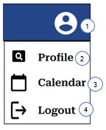

|  |  |  |  |  |
| --- | --- | --- | --- | --- |
| # | Item Name | Item Description | | Design Principle |
| 1 | Profile Icon Dropdown | | Predefined, see above. |  |
| 2 | Profile | | When clicked, the user will navigate to their “Profile” screen. | Roboto Serif, SemiBold,16pt, Black |
| 3 | Calendar | | When clicked, the user will navigate to the “Calendar” screen. | Roboto Serif, SemiBold,16pt, Black |
| 4 | Logout | | When clicked, the user will be logged out of the system and navigated to the “Login” screen. | Roboto Serif, SemiBold,16pt, Black |

2.2.1.1.3 Admin side navbar

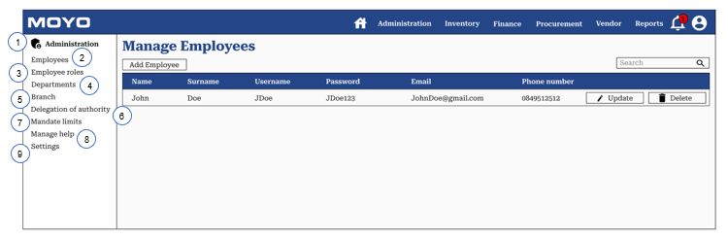

|  |  |  |  |
| --- | --- | --- | --- |
| # | Item Name | Item Description | Design Principle |
| 1 | Administration header | Contains the heading of the side navbar: “Administration header” | Roboto Serif, SemiBold,16pt, Black |
| 2 | Employees Option | When clicked, the user will navigate to the “Employees” screen. | Roboto Serif, Regular,16pt, Black |
| 3 | Employee Roles Option | When clicked, the user will navigate to the “Employee Roles” screen. | Roboto Serif, Regular,16pt, Black |
| 4 | Department Option | When clicked, the user will navigate to the “Department” screen. | Roboto Serif, Regular,16pt, Black |
| 5 | Branch Option | When clicked, the user will navigate to the “Branch” screen. | Roboto Serif, Regular,16pt, Black |
| 6 | Delegation of Authority Option | When clicked, the user will navigate to the “Delegation of Authority” screen. | Roboto Serif, Regular,16pt, Black |
| 7 | Mandate Limits Option | When clicked, the user will navigate to the “Mandate Limits” screen. | Roboto Serif, Regular,16pt, Black |
| 8 | Manage Help | When clicked, the user will navigate to the “Manage Help” screen. | Roboto Serif, Regular,16pt, Black |
| 9 | Settings Option | When clicked, the user will navigate to the “Settings” screen. | Roboto Serif, Regular,16pt, Black |

2.2.1.2 Homepage

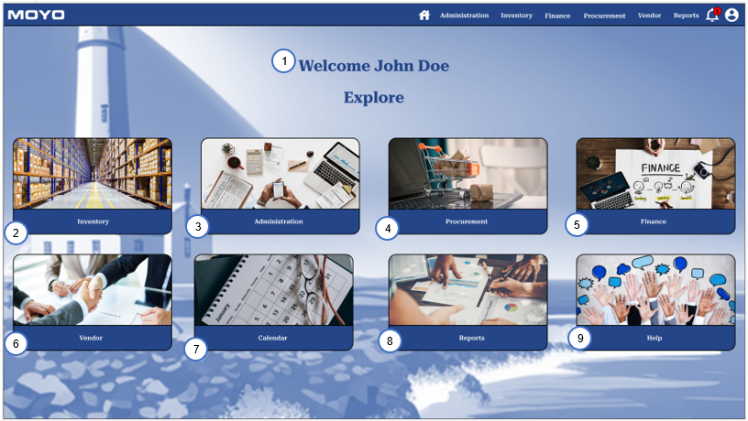

|  |  |  |  |
| --- | --- | --- | --- |
| # | Item Name | Item Description | Design Principle |
| 1 | Homepage heading – Welcome *Name* *Surname* | Contains the heading of the Homepage: “Welcome *Name* *Surname*” | Roboto Serif, Bold, 40pt, RGB(36,70,136) |
| 2 | Inventory Option | When clicked, the user will be navigated to the “Inventory” screen. | Roboto Serif, SemiBold,16pt, White |
| 3 | Administration Option | When clicked, the user will be navigated to the “Administration” screen. | Roboto Serif, SemiBold,16pt, White |
| 4 | Procurement Option | When clicked, the user will be navigated to the “Procurement” screen. | Roboto Serif, SemiBold,16pt, White |
| 5 | Finance Option | When clicked, the user will be navigated to the “Finance” screen. | Roboto Serif, SemiBold,16pt, White |
| 6 | Vendor Option | When clicked, the user will be navigated to the “Vendor” screen. | Roboto Serif, SemiBold,16pt, White |
| 7 | Calendar Option | When clicked, the user will be navigated to the “Calendar” screen. | Roboto Serif, SemiBold,16pt, White |
| 8 | Reports Option | When clicked, the user will be navigated to the “Report” screen. | Roboto Serif, SemiBold,16pt, White |
| 9 | Help Option | When clicked, the user will be navigated to the “Help” screen. | Roboto Serif, SemiBold,16pt, White |

2.2.1.3 Design principles for CRUD

Employees Screen

When you click the “Add Employee” button:

Alternative screen version of Create Employees model:

|  |  |  |  |
| --- | --- | --- | --- |
| # | Item Name | Item Description | Design Principle |
| 1 | Moyo Logo | Moyo logo placed in left upper corner of the modal | Image Top Left |
| 2 | Create Employees header | Screen heading of the screen/modal | Roboto Serif, Bold, 32pt, RGB(36,70,136) |
| 3 | Close icon button | On the modal screen allows the admin to cancel adding a new employee to the system. | Icon Top Right |
| 4 | Name Input | Allows the admin to input the name of the employee. | Roboto Serif, Regular,16pt, Black |
| 5 | Surname Input | Allows the admin to input the surname of the employee. | Roboto Serif, Regular,16pt, Black |
| 6 | Username Input | Allows the admin to input the username of the employee. | Roboto Serif, Regular,16pt, Black |
| 7 | Password Input | Allows the admin to input the password of the employee. | Roboto Serif, Regular,16pt, Black |
| 8 | Email Input | Allows the admin to input the email of the employee. | Roboto Serif, Regular,16pt, Black |
| 9 | Phone Number Input | Allows the admin to input the phone number of the employee. | Roboto Serif, Regular,16pt, Black |
| 10 | Role Dropdown list | Allows the admin to select an employee role for the employee. | Roboto Serif, Regular,16pt, Black |
| 11 | Department Dropdown list | Allows the admin to select a department the employee belongs to. | Roboto Serif, Regular,16pt, Black |
| 12 | Branch Dropdown list | Allows the admin to select a branch the employee belongs to. | Roboto Serif, Regular,16pt, Black |
| 13 | Save Button | When clicked the system validates and captured all the details entered and navigates the admin back to the “Employees” screen where the newly updated table is displayed | Roboto Serif, Regular,16pt, White |
| 14 | Cancel Button | Allows the admin to cancel adding a new employee to the system. | Roboto Serif, Regular,16pt, White |

When you click the “Update” button:

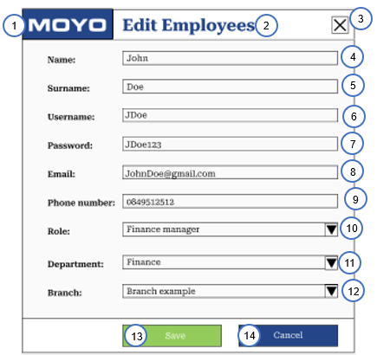

Alternative screen version of Edit Employees model:

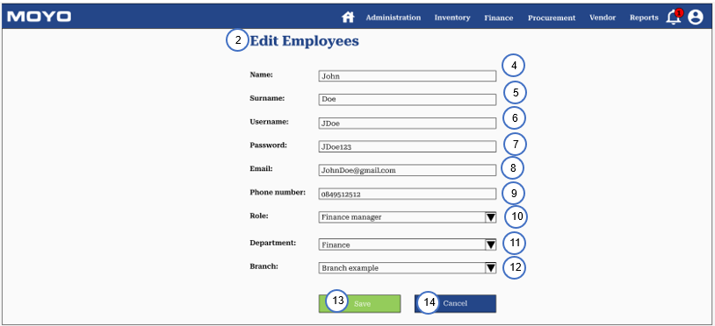

|  |  |  |  |
| --- | --- | --- | --- |
| # | Item Name | Item Description | Design Principle |
| 1 | Moyo Logo | When clicked, the user will be navigated to the “Home” screen. | Image Top Left |
| 2 | Edit Employees header | Screen heading of the screen/model | Roboto Serif, Bold, 32pt, RGB(36,70,136) |
| 3 | Close icon button | On the model screen allows the admin to cancel adding a new employee to the system. | Icon Top Right |
| 4 | Name Input | Allows the admin to input an updated name of the employee. | Roboto Serif, Regular,16pt, Black |
| 5 | Surname Input | Allows the admin to input an updated surname of the employee. | Roboto Serif, Regular,16pt, Black |
| 6 | Username Input | Allows the admin to input an updated username of the employee. | Roboto Serif, Regular,16pt, Black |
| 7 | Password Input | Allows the admin to input an updated password of the employee. | Roboto Serif, Regular,16pt, Black |
| 8 | Email Input | Allows the admin to input an updated email of the employee. | Roboto Serif, Regular,16pt, Black |
| 9 | Phone Number Input | Allows the admin to input an updated phone number of the employee. | Roboto Serif, Regular,16pt, Black |
| 10 | Role Dropdown | Allows the admin to assign a new employee role for the employee. | Roboto Serif, Regular,16pt, Black |
| 11 | Department Dropdown | Allows the admin to select a new department the employee belongs to. | Roboto Serif, Regular,16pt, Black |
| 12 | Branch Dropdown | Allows the admin to select a new branch the employee belongs to. | Roboto Serif, Regular,16pt, Black |
| 13 | Save Button | When clicked the system validates and captured all the details entered and navigates the admin back to the “Employees” screen where the newly updated table is displayed | Roboto Serif, Regular,16pt, White |
| 14 | Cancel Button | Allows the admin to cancel editing an employee detail on the system. | Roboto Serif, Regular,16pt, White |

When the “Delete” button is clicked on Employees Screen:

|  |  |  |  |
| --- | --- | --- | --- |
| # | Item Name | Item Description | Design Principle |
| 1 | Screen heading | Contains the heading of the screen: “DELETE EMPLOYEE” | Roboto Serif, SemiBold,24pt, White |
| 2 | “X” button | Allows the admin to cancel Deleting an employee from the system. | Top Right |
| 3 | Deletion Confirmation Question | Contains the question of asking the admin if they are sure they want to delete the selected employee. | Roboto Serif, Regular,16pt, White |
| 4 | “Yes” Button | When clicked, the system removes the employee from the database, and navigates the admin back to the employee table screen where the deleted item will no longer be shown. | Roboto Serif, Regular,16pt, White |
| 5 | “Cancel” Button | Allows the admin to cancel Deleting an employee from the system. | Roboto Serif, Regular,16pt, White |

2.2.2 Interface output design

2.2.2.1 Design Principles

|  |  |  |  |  |
| --- | --- | --- | --- | --- |
| Code | Element | Positioning | Text/Content | Formatting |
| ML | Moyo Logo | Top Left | Picture | Image |
| RT | Report Title | Center | Text: “Report Name” | Arial, 16pt, RGB(36,70,136) |
| RD | Date the report is generated | Center | Text: “Generated on” | Arial, 12pt, Black |
| RP | Time period the report is specified for | Center | Text: “Period” | Arial, 12pt, Black |
| RG | Generated graphs/tables | Center | Graph or table based on data from database | None |
| RE | End of report text | Center | Text: “**End of Report**” | Arial, 14pt, RGB(191,191,191) |

|  |  |
| --- | --- |
| **General Details** | |
| **Report Number** | 1.3 |
| **Report Name** | Forgot password |
| **Short Description** | This report describes the event of the user request to reset their password where they are navigated to a new screen and the system generates an email that is send to the user that contains the code that they need to be able to reset their password. |
| **Frequency** | Ad hoc |

2.2.2.1.1 Update password email

|  |  |  |  |  |  |
| --- | --- | --- | --- | --- | --- |
| **Selection Criteria** | | | | | |
| **Criteria** | **Default** | **Type** | **All Selection** | **Multiple Selection** | **Values** |
| None | N/A | N/A | N/A | N/A | N/A |

|  |  |  |  |  |  |
| --- | --- | --- | --- | --- | --- |
| **Report Fields** | | | | | |
| **Field Name** | **Format** | **Maximum Length** | **Justified** | **Leading Zero Suppression** | **Source** |
| Email Title | Varchar | 32 | Left | N/A | Predefined |
| From | Varchar | 32 | Left | N/A | Predefined |
| To | Varchar | 32 | Left | N/A | Employee_Email |
| Print Icon | Image | N/A | Top Right | N/A | Predefined |
| New Window Icon | Image | N/A | Top Right | N/A | Predefined |
| Date&Time | Varchar | N/A | Right | N/A | Predefined |
| Star Icon | Image | N/A | Right | N/A | Predefined |
| Reply Icon | Image | N/A | Right | N/A | Predefined |
| Expand Menu Icon | Image | N/A | Right | N/A | Predefined |
| Content | Varchar | 280 | Left | N/A | Predefined |
| Moyo logo | Image | N/A | Left | N/A | Predefined |
| Disclaimer Content | Varchar | 975 | Left | N/A | Predefined |
| Reply Button | Button | N/A | Left | N/A | Predefined |
| Forward Button | Button | N/A | Left | N/A | Predefined |

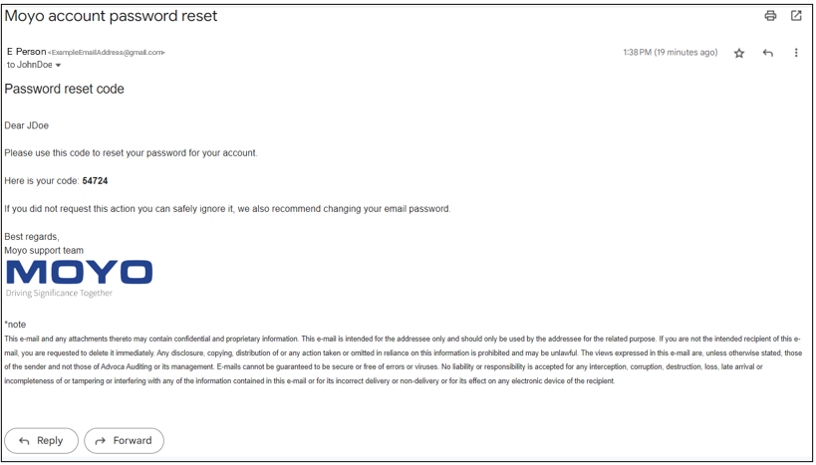

2.2.2.1.2 Generate BEE spend report

|  |  |
| --- | --- |
| **General Details** | |
| **Report Number** | 7.2 |
| **Report Name** | Generate BEE spend report |
| **Short Description** | A report that will display an overall BEE spend summary table, a MBA BEE spend summary table, a VEN BEE spend summary table, a ENG BEE spend summary table, a MTS BEE spend summary table, a CPT BEE spend summary table, with all table containing columns ranging from 1-8, a non-compliant, and a total column as well as the following rows procurement spend, procurement %, and procurement entitlement. This is followed by a total procurement entitlement BEE level This data will be retrieved from the system’s database. |
| **Frequency** | Ad hoc |

|  |  |  |  |  |  |
| --- | --- | --- | --- | --- | --- |
| **Selection Criteria** | | | | | |
| **Criteria** | **Default** | **Type** | **All Selection** | **Multiple Selection** | **Values** |
| Start Date | Current Date | Date Picker | No | No | Any date, before or equal to the current date |
| End Date | Current Date | Date Picker | No | No | Any date, before or equal to the current date |

|  |  |  |  |  |  |  |
| --- | --- | --- | --- | --- | --- | --- |
| **Report Fields** | | | | | | |
| **Field Name** | **Format** | **Maximum Length** | **Justified** | **Design Principles** | **Leading Zero Suppression** | **Source** |
| Moyo Logo | Image | N/A | Top Left | Image Left | N/A | Predefined |
| Report Title | Varchar | 30 | Center | Arial, 16pt, RGB(36,70,136) | N/A | Predefined |
| Generated on | DateTime | dd/mm/yyyy | Center | Arial, 12pt, Black | N/A | System.DateTime.now on generation of report |
| Period | DateTime | dd/mm/yyyy - dd/mm/yyyy | Center | Arial, 12pt, Black | N/A | Report.Start_Date And Report.End_Date** |
| Table Header | varchar | 30 | Center | Arial, 16pt, RGB(36,70,136) | N/A | Predefined |
| Procurement spend | Decimal | N/A | Left | Arial, 11pt, Black | N/A | Predefined |
| Procurement (%) | Decimal | N/A | Left | Arial, 11pt, Black | N/A | Predefined |
| Procurement Entitlement | Decimal | N/A | Left | Arial, 11pt, Black | N/A | Predefined |
| Column Chart Title | Varchar | 30 | Center | Arial, 16pt, RGB(36,70,136) | N/A | Predefined |
| Chart | Column Chart | None | Center | None | N/A | Total procurement entitlement per BEE level |
| Pie Chart Title | varchar | 30 | Center | Arial, 16pt, RGB(36,70,136) | N/A | Predefined |
| Chart | Pie Chart | None | Center | None | N/A | The percentage of non-compliance per entity |

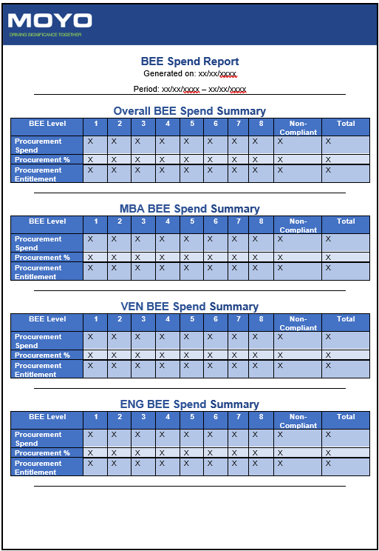

2.2.2.1.3 Generate Budget Variance Report

|  |  |
| --- | --- |
| **General Details** | |
| **Report Number** | 7.6 |
| **Report Name** | Generate Budget Variance Report |
| **Short Description** | A report that shows the month, budget category, budget amount, actual spent, variance (R) and variance (%) as columns of a table and populated with data using the database. A line chart containing each month budgeted expenses and actual expenses is displayed underneath the table. Lastly a clustered column chart based on budget category, actual expenses and the variance (R) is displayed underneath the previous chart. |
| **Frequency** | Ad hoc |

|  |  |  |  |  |  |
| --- | --- | --- | --- | --- | --- |
| **Selection Criteria** | | | | | |
| **Criteria** | **Default** | **Type** | **All Selection** | **Multiple Selection** | **Values** |
| Start Date | Current Date | Date Picker | No | No | Any date, before or equal to the current date |
| End Date | Current Date | Date Picker | No | No | Any date, before or equal to the current date |

|  |  |  |  |  |  |  |
| --- | --- | --- | --- | --- | --- | --- |
| **Report Fields** | | | | | | |
| **Field Name** | **Format** | **Maximum Length** | **Justified** | **Design Principles** | **Leading Zero Suppression** | **Source** |
| Moyo Logo | Image | N/A | Top Left | Image Left | N/A | Predefined |
| Report Title | Varchar | 30 | Center | Arial, 16pt, RGB(36,70,136) | N/A | Predefined |
| Generated on | DateTime | dd/mm/yyyy | Center | Arial, 12pt, Black | N/A | System.DateTime.now on generation of report |
| Period | DateTime | dd/mm/yyyy - dd/mm/yyyy | Center | Arial, 12pt, Black | N/A | Report.Start_Date And Report.End_Date** |
| Table Header | varchar | 30 | Center | Arial, 16pt, RGB(36,70,136) | N/A | Predefined |
| Month | DateTime | d-Mth | Left | Arial, 11pt, Black | N/A | Predefined |
| Budget Category | Varchar | 32 | Left | Arial, 11pt, Black | N/A | Predefined |
| Budget Amount (R) | Decimal | N/A | Left | Arial, 11pt, Black | N/A | Predefined |
| Actual Spent (R) | Decimal | N/A | Left | Arial, 11pt, Black | N/A | Predefined |
| Variance (R) | Decimal | N/A | Left | Arial, 11pt, Black | N/A | Predefined |
| Variance (%) | Decimal | N/A | Left | Arial, 11pt, Black | N/A | Predefined |
| Line chart Title | Varchar | 30 | Center | Arial, 16pt, RGB(36,70,136) | N/A | Predefined |
| Chart | Line chart | None | Center | None | N/A | Monthly total budget expenses and actual expenses |
| Clustered Column Chart Title | varchar | 30 | Center | Arial, 16pt, RGB(36,70,136) | N/A | Predefined |
| Chart | Clustered Column Chart | None | Center | None | N/A | Each budget category’s budgeted Amount, Actual expenses and the variance (%) |

## 2.3 Conclusion

In conclusion this section provided an overview of how the inputs and outputs designs look and what principles need to be followed to achieve the desired screen designs.

3. Entity Relationship Diagram

## 3.1 Introduction

This section goes in depth into a visual representation of our technical ERD. The ERD complies with referential integrity and is fully attributed as well as in 3rd normal form. This serves as an indication of how we will structure our database.

## 3.2 Entity relationship Diagram

## 3.3 Conclusion

This concludes the entity relationship diagram with all the entity tables and relationships between the entities within the system that we will develop.

4. Technical specifications

## 4.1 introduction

In this section, the different technologies which will be used in the system will be discussed. The discussion of these technologies will serve to create a greater understanding of how these technologies will be integrated into the system, and the purpose which they will serve in helping to create a comprehensive system as was detailed in previous specification documents.

## 4.2 Technical specification of chosen elements

# 4.2.1 SQL

### 4.2.1.1 What is SQL?

SQL, or Structured Query Language, is a programming language used for managing, storing, and processing data in a relational database. SQL code takes the form of ‘statements’, and these statements are used to manipulate the data stored in the database to achieve the user’s goals. For this project, the DBMS of choice will be SQL Server.

### 4.2.1.2 What is SQL Server?

SQL Server is a relational database management system developed by Microsoft that expands upon the functionalities of SQL. It expands upon SQL in the form of Transact-SQL (T-SQL), which is Microsoft’s extension of SQL which adds additional features to base SQL and differs slightly syntactically.

### 4.2.1.3 How the database is set up

We will be making use of a code-first approach to create the database. This means that the table schemas of the database will be defined in our .Net Core API based on the code in our models, and the database will be generated by making use of migrations, which will automatically generate SQL code according to the schemas defined in the models of the API. This approach will ensure that our database is always exactly in line with the code in our models and will reduce the risk of errors occurring.

### 4.2.1.4 Connection of the database to the .Net API

To connect the database to the API, the following steps will need to be undertaken:

Step 1: Install the MySqlConnector, Microsoft.EntityFrameworkCore, and Microsoft.EntityFrameworkCore.SqlServer NuGet packages in the .Net API

Step 2: Add a connection string to the appsettings.json file in the API. The following format should be followed:



Step 3: Open the package manager console and run commands to add migrations and update the database. The following two commands should be executed consecutively to ensure success:

“add-migration initial

“update-database”

By following the above steps, the database will be connected to the API, and SQL code will be generated to create the database according to the models of the API.

# 4.2.2 Angular

### 4.2.2.1 What is Angular?

Angular is a popular typescript-based web application framework developed by Google to build web applications. It is a component-based framework where each component spans a specific part of the UI and its associated behaviour. Typescript provides a clearly defined structure for its users, which aids in the development and maintenance of large projects where there are multiple developers working on the same program.

### 4.2.2.2 Why use Angular?

Angular will be used as the framework of choice to develop the entire front-end of our app due to the ease of which it can be implemented, as well as its ability to support many developers working on the same program due to its strictly defined structure. Whereas with other frameworks, the user decides how the program is structured themselves which can lead to issues when maintaining the program, Angular lays out the general structure for its users which will aid in readability for future developers working on the app. Using the Angular CLI, we will not have to worry about configurations, dependencies, and the like. Angular also comes in a very complete form, meaning we do not have to worry about installing different packages to take care of things like app routing.

# 4.2.3 .Net Core Web API

### 4.2.3.1 What is .Net Core Web API?

.Net Core is an open-source, cross-platform web-development framework used for building applications which connect to the web. Using this framework, we will be able to build an application programming interface (API) using the REST architecture to serve as the backend system to our Angular frontend mentioned above.

### 4.2.3.2 What is the REST architecture?

REST, which stands for representational state transfer, is an architectural style used to define the ways in which requests are handled over the web. When a request is made to a RESTful API, which is the name we prescribe to APIs which follow this REST architecture, a representation of the state is transferred to the endpoint. This representation can be transferred in a multitude of different formats, however the most common format, which is also the format that we will be working with, is JavaScript Object Notation (JSON). Once this information has been transferred to the endpoint, some kind of processing will take place to achieve the desired results, such as writing information to a database.

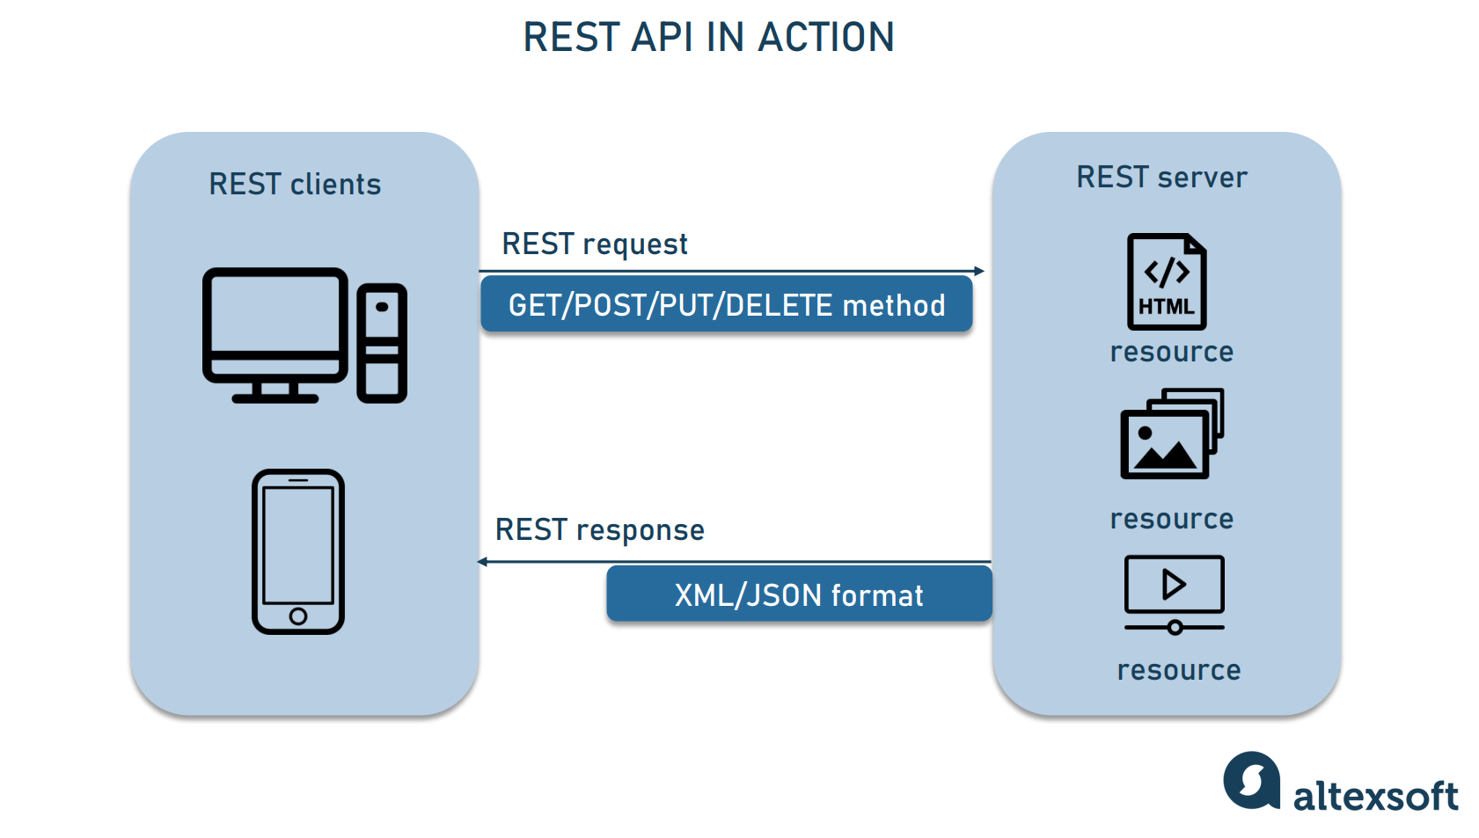

As seen in the above image, the information is transferred to the REST server (endpoint) via means of different methods. Each of these methods sit on, and take place over URLS, and information being transferred over a given URL is the crux of how REST works. Image available at: <https://www.altexsoft.com/blog/rest-api-design/>

### 4.2.3.3 How does this connect to the database and the frontend?

In order to connect to the frontend, the API will need to be running and the URL of this API will need to be known and saved as a variable in the Angular app. This URL will be stored in a “data-service” class, which forms part of the data layer to ensure simplified access to data and assist in maintenance of the program. Connection to the database will take place by means of the packages and connection string mentioned above in the SQL section.

#### 4.2.3.3.1 example of API URL in data service class

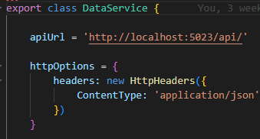

The above picture is an example of how a WEB-API connects to the Angular app. It is available online at: <https://www.c-sharpcorner.com/article/build-an-app-using-angular-10-net-core-web-api-sql-server/>

# 4.2.4 ASP.Net Identity

### 4.2.4.1 What is ASP.Net Identity?

ASP.Net Identity is an API that deals with user authentication. It provides functionality for managing passwords, tokens, roles, 2-factor authentication, email confirmation amongst other things. Primarily it will be implemented into our project in order to manage passwords (specifically password hashing), as well as providing 2-factor authentication to increase the security of our application.

### 4.2.4.2 Why ASP.Net Identity?

ASP.Net Identity will be used as opposed to other forms of user authentication and authorization because it will seamlessly integrate into our API given it is also developed by Microsoft. This means that it has extensive documentation available for us to troubleshoot any problems, and it was built to easily integrate into .Net Core APIs without any problems. Because it is just a package, it can easily be implemented into the .Net Core API and be used after being imported.

### 4.2.4.3 How to use ASP.Net Identity

#### 4.2.4.3.1 Packages needed:

* Microsoft.AspNet.Identity.EntityFramework
* Microsoft.AspNet.Identity.Core
* Microsoft.AspNet.Identity.OWIN

# 4.2.5 ML.NET

### 4.2.5.1 What is ML.NET?

ML.NET is an open-source cross-platform framework developed by Microsoft for .NET developers which allows you to implement machine learning models using C# or F#. It has a variety of uses, such as sales forecasting, price prediction, product recommendation and more, however, for the purposes of this project, we will mainly be using it for forecasting stock.

### 4.2.5.2 Why use ML.NET?

We will be using ML.NET because it provides us with a pre-trained model that comes ready-to-use out of the box. This means that we will not have to spend unnecessary effort attempting to understand the underlying principles behind machine learning and training the model on data ourselves. In addition, like many of the other technologies used, ML.NET is developed by Microsoft and is free, so it will seamlessly integrate into the program given the correct steps are followed.

### 4.2.5.3 How to use ML.NET

#### 4.2.5.3.1 Packages needed:

* Microsoft.ML
* Microsoft.ML.TimeSeries
* Microsoft.ML.AutoML

Detailed information on how to set up ML.NET forecasting can be found at the following link:

<https://github.com/dotnet/machinelearning-samples/tree/main/samples/csharp/end-to-end-apps/Forecasting-Sales?WT.mc_id=dotnet-35129-website>

# 4.2.6 Npmjs – Scheduling Component

### 4.2.6.1 What is Npmjs?

Npmjs is an Angular scheduling component used for simplified resource grouping scheduler. This Makes use of a calendar component for a user-friendly experience that would allow for scheduling and rescheduling of events and grouped events for each day, week, month, and year. This allows for effortless customization with built in templates.

### 4.2.6.2 Why use Npmjs.

We will make use of the data from our database that was collected form our views on the system. This data will include events like procurement request date, procurement approval/rejection date, required payment dates, delegation of authority start and end date, mandate limits date etc. This data will then be displayed on the Npmjs calendar item.

### 4.2.6.3 How to use Npmjs

#### 4.2.6.3.1 Packages Needed.

* npm install angular-calendar-scheduler date-fns –save
* yarn add angular-calendar-scheduler date-fns

#### 4.2.6.3.2 Providers

* { provide: LOCALE_ID, useValue: 'en-US' },
* { provide: MOMENT, useValue: moment }

#### 4.2.6.3.3 Windows Imports.

* import { CalendarModule } from 'angular-calendar';
* import { SchedulerModule } from 'angular-calendar-scheduler';
* import moment from 'moment';
* CalendarModule.forRoot(),
* SchedulerModule.forRoot({locale: 'en', headerDateFormat: 'daysRange’}),

#### 4.2.6.3.4 Example and link to demo.

Npmjs link demo: [https://angular-calendar-scheduler-demo.stackblitz.io](https://angular-calendar-scheduler-demo.stackblitz.io/)

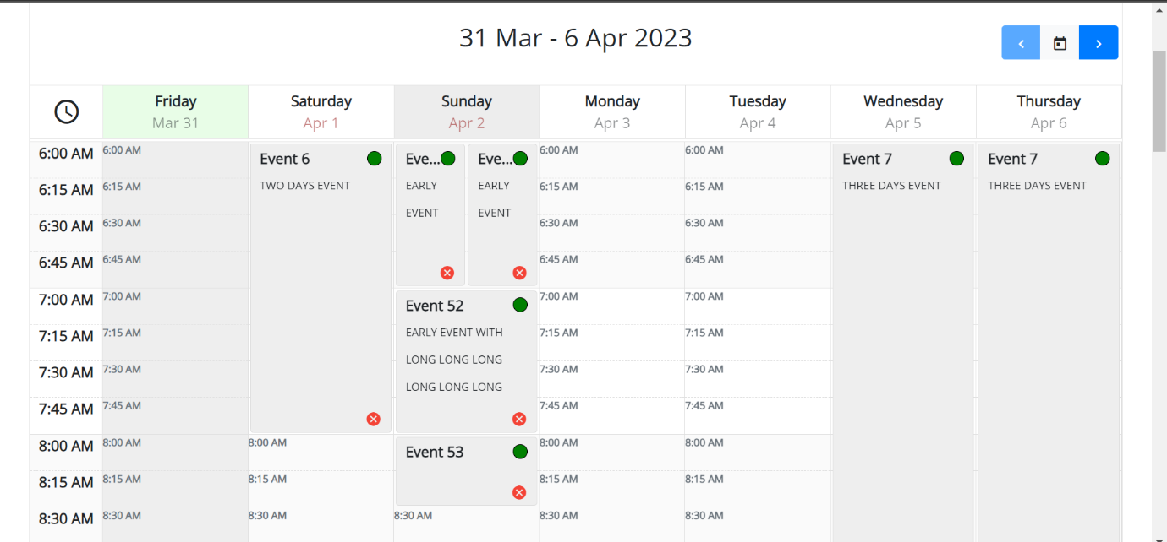

# 4.2.7 Email kits and components - NET Core.Mailkit and Emails mailto

### 4.2.7.1.1 What is Mailkit?

Mailkit is a cross-platform mail library built on top of the Mimekit. Mailkit is an open source based on the email framework of .NET. This will allow us to send automatic default emails through the use of the system. We can thus send emails by using SMTP that is generated by our system.

### 4.2.7.1.2 Why use Mailkit?

Mailkit is a powerful and flexible way to send and receive emails in .NET. Mailkit allows for added attachments, message priorities, handling HTML and Plain text messages this helps for emails like Reminders, procurement requests, procurement approvals/rejections, require payments etc. Mailkit is relatively secure using SSL and TSL encryption. Mailkit is easy to use and can handle large amounts of messages without slowing down.

### 4.2.7.1.3 How to use Mailkit.

#### 4.2.7.1.3.1 Requirements

* Visual studio 2022 community edition
* .NET 6 Core Framework

#### 4.2.7.1.3.2 Packages Needed

* Install-Package MailKit
* dotnet add package MailKit
* <PackageReference Include="MailKit" Version="<Version-Tag-Here>" />
* Install-Package RazorEngineCore
* dotnet add package RazorEngineCore
* <PackageReference Include="RazorEngineCore" Version="<VERSION-TAG-HERE>" />

#### 4.2.7.1.3.3 Example and link

Example Link: <https://blog.christian-schou.dk/send-emails-with-asp-net-core-with-mailkit/>

# 4.2.7.2 Mailto

### 4.2.7.2.1 What is Mailto?

Mail to is a URI used for emails. Mailto will be used to create hyperlinks on our website system that will allow users to send an email to a specific address from the HTML document without having to copy or enter the details over again.

### 4.2.7.2.2 Why use Mailto?

Mailto provides an easy and beneficial way for the users of our system to contact others with our system using email. Users can simply use mailto to compose an email without even having to enter or reenter the recipient email address into their email client. This is especially useful for customer support, submitting a report, or providing feedback. This increases the overall user experience of the system.

### 4.2.7.2.3 How to use Mailto.

#### 4.2.7.2.3.1 HTML Links

* <a href="mailto:email@example.com">Send Email</a>
* <a href="mailto:email@example.com?cc=secondemail@example.com, anotheremail@example.com, &bcc=lastemail@example.com&subject=Mail from our Website&body=Some body text here">Send Email</a>

#### 4.2.7.2.3.2 Packages and imports

* import 'dart:io';
* import 'package:mailto/mailto.dart';
* import 'package:url_launcher/url_launcher.dart';

#### 4.2.7.2.3.2 Examples and links

Link for mailto example: <https://pub.dev/packages/mailto>

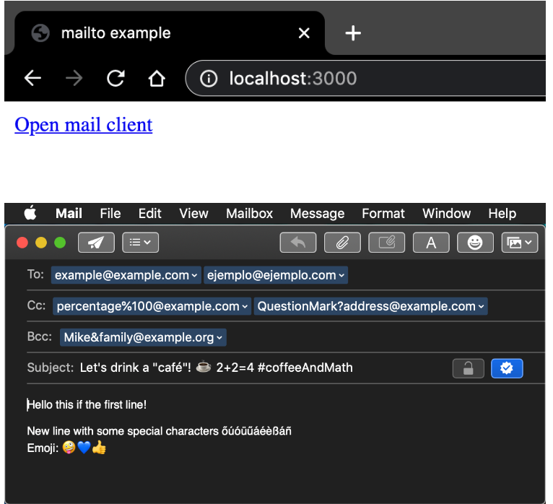

# 4.2.8 Microsoft Azure – Cloud Computing Service

### 4.2.8.1.1 What is Azure?

Microsoft Azure is a cloud computing service that our client makes use of. This service help Moyo to optimize and manage their cloud environments. The services that Azure has to offer are cloud-based services, including computing, storage, networking, analytics, databases, and machine learning etc. This allows us to run our system on a stable and secure infrastructure.

### 4.2.8.1.2 Why use Azure?

Microsoft Azure has 67 regions (South Africa north being one of them) 160+ Databases and 3+ Availability zones. Azure makes use of global networks of their cloud environments. Moyo already makes use of this service Azure provides and would like it implemented within the new procurement system we are developing. This will provide Moyo with scalability, flexibility, security, cost-effectiveness, integration with other Microsoft services, and advanced AI and machine learning capabilities within our system.

### 4.2.8.1.3 How to use Azure.

By making use of the Moyo Microsoft Azure account we can make use of all the features azure has to offer. You Can use the guided approach or command prompts using PowerShell. With the guided approach you can use the computer services like SQL Databases, app services, storage accounts etc. We can use azure for cost management and setting budgets by making use of their tools.

Microsoft Azure link: <https://azure.microsoft.com/en-gb/free/search/?&ef_id=Cj0KCQjwz6ShBhCMARIsAH9A0qV-90UpXvibx-MQXxubWC3dUlu2jesIy2WMEV4tvK1u2o5nzYuBJEkaAuwHEALw_wcB:G:s&OCID=AIDcmmck5pq7og_SEM_Cj0KCQjwz6ShBhCMARIsAH9A0qV-90UpXvibx-MQXxubWC3dUlu2jesIy2WMEV4tvK1u2o5nzYuBJEkaAuwHEALw_wcB:G:s&gclid=Cj0KCQjwz6ShBhCMARIsAH9A0qV-90UpXvibx-MQXxubWC3dUlu2jesIy2WMEV4tvK1u2o5nzYuBJEkaAuwHEALw_wcB>

# 4.2.9 Windows forms

### 4.2.9.1.1 What is Windows forms?

Windows forms is a UI framework that creates rich desktop client apps for Windows. Windows forms support a wide arrange of app development features like controls, graphics, data binding, user inputs etc. windows forms help with building web desktop apps based on visual designer like visual studios. It provides an easy drag and drop system of visual controls.

### 4.2.9.1.2 Why use Windows forms?

We will be using windows forms to be able to backup and restore data that is within our system. Thus, when someone like the admin wishes to backup the data in the system, we will make use of the windows file explorer and from there we can choose the location we wish to store the backup. To restore data to the system a person like the admin would make use of the windows file explorer and go to the location of the backed-up data and restore the systems data with that backed-up data that was selected.

### 4.2.9.1.3 How to use Windows forms.

#### 4.2.9.1.3.1 Implementation

* GitHub
* .NET 6 Visual studios 2022
* .NET Framework 4 supported by visual studios 2022

#### 4.2.9.1.3.2 system requirements

* Using System.Windows.Forms

#### 4.2.9.1.3.2 Example and link

Windows Forms link: <https://learn.microsoft.com/en-us/dotnet/desktop/winforms/overview/?view=netdesktop-7.0>

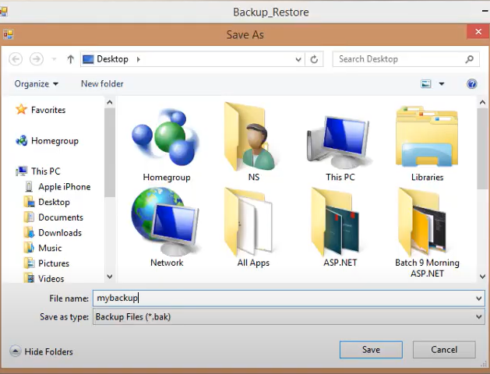

# 4.2.10 ASP.NET core Export to excel package

### 4.2.10.1.1 What is Export to excel?

With export to excel (EPPLUS package) we wish to achieve the ability to export data from the system into a csv file which we can use in excel. This is a package that will be used within ASP.NET core that can be downloaded and called in the app settings.

### 4.2.10.1.2 Why use Export to excel?

We use this EPPLUS package in our system for a user to be able to export data from the system directly into a .csv/excel file. This is needed for the budgets data as well as user data within the system or even for certain reports. This is useful to the client MOYO as they would like to have such data in an excel format.

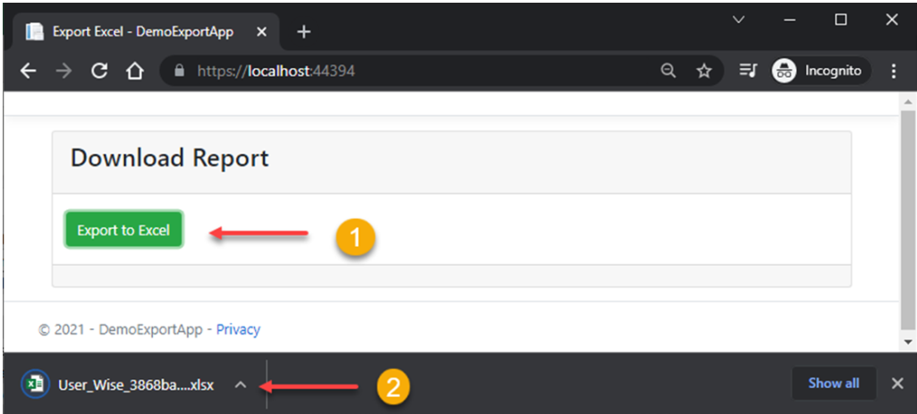

### 4.2.10.1.3 How to use Export to excel.

#### 4.2.10.1.3.1 Packages

* Microsoft.EntityFrameworkCore
* Microsoft.EntityFrameworkCore.SqlServer
* EPPlus

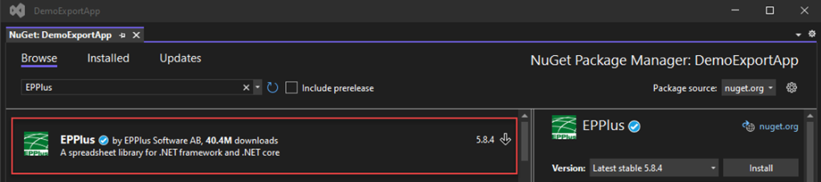

#### 4.2.10.1.3.1 Examples and link

How to Export Data to Excel in ASP.NET Core Link: https://tutexchange.com/how-to-export-data-to-excel-in-asp-net-core/<https://tutexchange.com/how-to-export-data-to-excel-in-asp-net-core/>

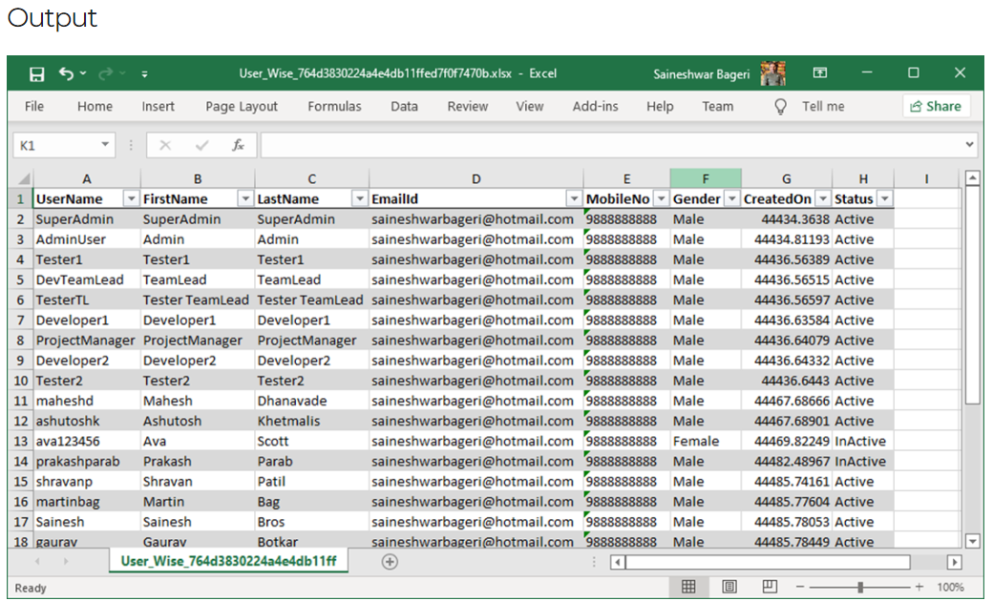

## 4.3 conclusion

This then concludes the technical specification that will take place in our procurement system. This section helps us to pinpoint the technical element that was chosen from the complexity matrix that will be used within our system, this includes the front-end and back-end development of the system.

5. Network layout specification

## 5.1 introduction

In this section we provide a visual representation of the current network layout at MOYO head office Jean Avenue Centurion. This will provide a clear view of how the network is structured at MOYO.

## 5.2 Network layout

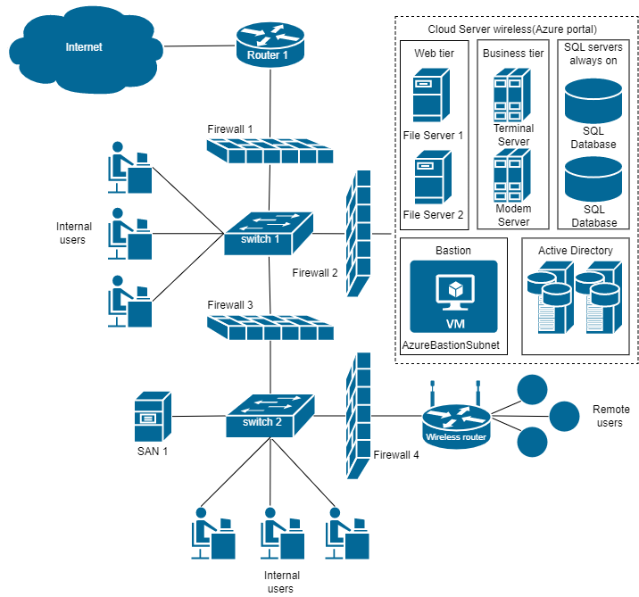

## 5.3 conclusion

This concludes the network layout specification section of this document.

6.Updated Complexity matrix

## 6.1 introduction

In this section we show the updated complexity matrix with all the technology that we will be using, the Procion system. This shows each technical requirements that the system will have and the Total complexity mark of the system.

## 6.2 complexity matrix



## 6.3 conclusion

This concludes the updater complexity matrix section of this document.

7. Document Conclusion

This concludes the iteration 3 document regarding the technical specifications of the Procion system. This Give Valuable insight for understanding how the system would function and how the users will interact with the various function within the system as well as how we will store valuable information on the technical side of the system.

8. Team Sign off

***PROCION SYSTEM: Technical Specification***

We, team 11, understand and acknowledge, have reviewed the information contained in the document (Technical Specifications), and we confirm and understand the contents and that the information provided is true.

**BY SIGNING BELOW, WE AGREE TO THE FOLLOWING:**

1. We understand the goals and the objectives of the project, as well as the specific tasks and responsibilities assigned to us.
2. We agree that our assigned tasks have been completed and meet the required quality standards.
3. We agree that any issues, risks, and concerns have been appropriately addressed and resolved.
4. Acknowledge that any changes or revisions to the document have been made and agreed upon by the project team.
5. That each team member has contributed equally to the iteration

|  |  |  |  |  |
| --- | --- | --- | --- | --- |
| **Signed by:** | | | | |
| **Name:** Jason vd Merwe | **Name:** Leon Combrinck | **Name:** Bupe Chindongo | **Name:** Werner Schutte | **Name:** Emil Wonigkeit |
| **Date:** 2023-04-11 | **Date:** 2023-04-11 | **Date:** 2023-04-11 | **Date:** 2023-04-11 | **Date:** 2023-04-11 |
| **Signature:** | **Signature:** | **Signature:** | **Signature:** | **Signature:** |

9. Client Document Sign OFF

***PROCION SYSTEM: Technical Specification***

***Business Name: MOYO Business Advisory***

I, _____________________________________, hereby confirm that I have read the document and agree that the information contained therein is complete, accurate and meets the requirements of the project.

**BY SIGNING I CONFIRM THAT:**

1. **I have reviewed the deliverable as outlined in this project.**
2. **I accept the deliverable as complete and satisfactory.**

|  |
| --- |
| **SIGNED BY:** |
| **Name:** |
| **Date:** |
| **Signature:** |